Part 3. Selecting appropriate ways of processing and presenting fieldwork data
- Add titles onto the graphs. E.g. Histogram has been done
- Use the information below to answer the questions. You need to know advantages and disadvantages of each type of graph.
Technique | Use WHEN DID WE USE | Advantages | Disadvantages
Bar charts  (gap between data bars)  Locational Bar Charts | To show distinct/discreet data.  Can compare a number of different categories.  CAN LOCATE ON A MAP.  PEDESTRIAN COUNT | good visual results / easy to make sense of data.  Show relationships between 2 or more variables (if bars are side by side)  Show proportions.  Can show positive and negative values.  Simple to construct and understand. | Plotting too many bars makes it appear cluttered- less easy to interpret.  If there is a wide scale (range) of data impact lost as it is difficult to read accurately.
Histogram  (no gaps between bars) | To show continuous data (so same shading). | Same as bar chart.  Also shows continuous data e.g. rainfall on a climate graph. | Same as bar chart.  Hard to show large/small data on same graph due to the scale required.
Divided bar graph | SMOOTHNESS OF PEBBLES  LAND USE % FOR EACH AREA | Can visually compare the proportions of a segment between bars.  Easy to read if smaller number of classes/ segments are used.  Easy to construct if put into %. | More difficult to compare if not converted into %.  If too many classes/ segments are created it can be difficult to read
Line graph | Shows continuous data e.g. over time  VELOCITY OF THE RIVER AS WE MOVED DOWNSTREAM. | Can show multiple sets of data on the same graph.  Shows peaks/troughs and trends/patterns at a glance | Does not show direction of movement  Problem if numbers vary greatly/need to choose appropriate scale
Annotated Photos /  Field sketches  Can be located on a map. | Illustrates change.  CAN LOCATE ON A MAP  CHANGES TO THE WIDTH OF THE RIVERS | Clear visual tool illustrates change over time.  Highlight important features. | Can be biased in the photos selected / features included, so not a true representation of the area. .
Pie Chart  Locational Pie Charts | Shows distinct data that can be divided into parts  CAN LOCATE ON A MAP  SMOOTHNESS OF PEBBLES | Quick visual impression of results  Clearly shows larger/smaller groups | Less than 3 segments look simplistic.  If many segments a similar size; it is hard to interpret.  Difficult to assess %.  Difficult to make comparisons between pie charts where there are lots of segments
Scatter graph | Shows relationship between two sets of data (correlations)  RELATIONSHIP BETWEEN VELOCITY AND WIDTH OR DEPTH OR SMOOTHNESS OR PEBBLE SIZE ETC | Best fit line gives visual guide to strength of relationship  Clearly shows anomalies | Need paired data  Need enough points to show a relationship  Best fit line not always clear
Dispersion graphs | Shows range of a set of data  SIZE OF PEBBLES LONG AXIS.  OPIONON ABOUT RIVERSIDE. | Shows if data is grouped or dispersed.  Can compare sets of data | Not as good for a wide range of data.
Radar graphs | A way of displaying multiple variable quantities  ENVIRONMENTAL IMPACT ASSESSMENT | Very visual – easy to see patterns  Easy to compare data sets as they over lay. | Can be difficult to construct.  Can be difficult to read if too many areas plotted.
Cross section area | DEPTH AND WIDTH OF THE RIVER CHANNEL. | Clear visual tool to see whole cross section esp in bends. | Depth sampling may not be accurate enough.
Quantitative data =
Qualitative data =

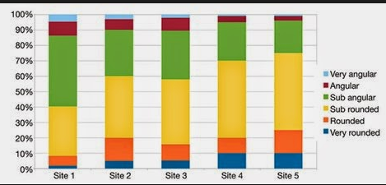
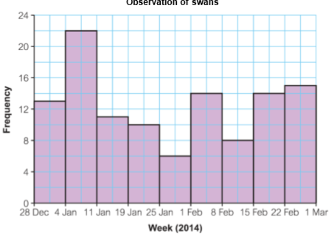
Histogram
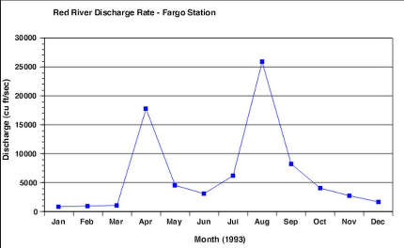
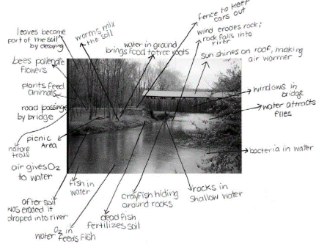
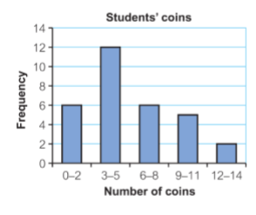
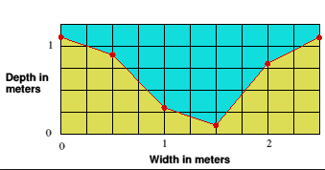
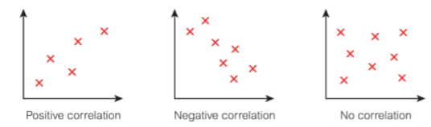
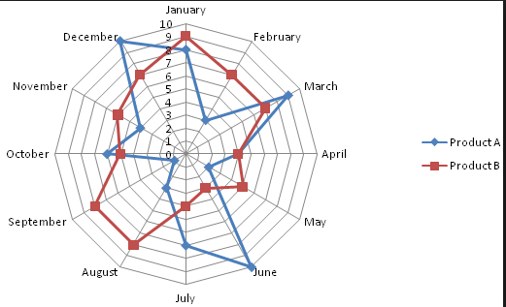
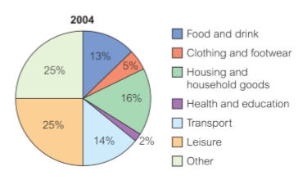
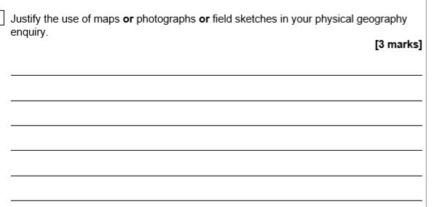
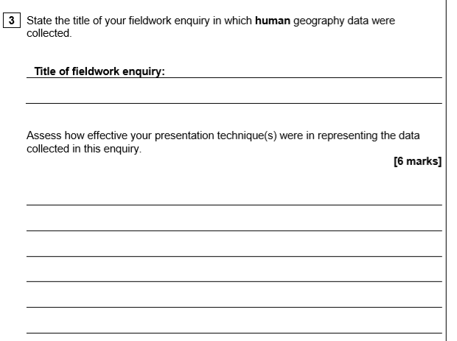

WWW:

EBI:

Improvement:

