Part 2. Selecting methods, measuring and recording data appropriate to the chosen enquiry.
- Extend ideas from the sentence starters.
- For completed answers highlight the point and the development.
- Try the questions without help.

Description – How you collected the data, what did you do, step by step.
Justification – Why you collected the data. (how does it help to answer the question).
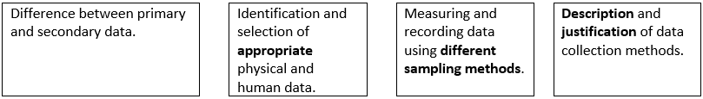

Random – Everyone there has equal chance of being picked. (can be Biased)
Volunteer – Choosing to be picked (not a representative sample).
Systematic - Every nth person / shop / rock (WE SHOULD HAVE DONE THIS FOR PEBBLES AND CLONE TOWN)
Stratified – Proportional to the population (Best method but difficult to do correctly).
Physical – width, depth, wetted perimeter, velocity, pebble size and shape, gradient.
Human- Pedestrian count, Land-use, Environmental Impact Survey, Clone Town, photos, census data, houses prices etc
Primary data - you have collect yourself (velocity of the river, width of the river, pedestrian count, Environmental impact survey).
Secondary data - Data not collected by yourself (weather reports, previous river data, census data, newspaper articles).

State the title of your fieldwork enquiry in which physical / human geography data were collected. | PHYSICAL  How do the characteristics of the Cound Brook change from site 1-6? (and does it match the Bradshaw model?) | HUMAN  Has the regeneration of the riverside area of Stafford been successful?
Describe a data collection method.  (2 marks)  P+D | Velocity – We measured a …… m stretch of river marked out with poles. Using …………, we timed how long it took to travel the …… m. This was done …….. times to get an average result to improve ………………………….  Depth – We used a systematic sample to measure 5 points along the width of the river. Using a  ……………. (aligned with the flow) we measured from the ………………………………… to the river bed. | Pedestrian count – Using a ………………………………. We timed 3 minutes in each location. On a tally  ……………… we recorded how many people walked past in the ………… minutes. We did this ………  Times to improve the average. We didn’t count ………………………………………………… because ……….  …………………………………………………………………………………………………………………………………………………….
Justify a primary data collection method of your enquiry.  (2 marks)  P+D | Velocity – We measured velocity to explore the link between the speed of the river and the rate of erosion (e.g. to see if lateral erosion ……………….. as the width of the river gets wider.) Velocity was used to allow us to calculate the rivers discharge (which is ………………………………………………………………  ……………………………………………………..) We could then compare this to the Bradshaw Model.  Depth - This allowed us to draw a cross section of the river and calculate the wetted perimeter and compare to the ……………………………. Model. | Environmental Quality Survey – Allowed all 3 areas to be compared and provided quantitative data for analysis. Based on specific targeted criteria e.g. vandalism, street lighting.  Land-use assessment – Allowed the land-use to be categorised to calculate the % empty shops or the amount of derelict land to assess the environmental impact of the regeneration.  Questionnaire – To assess the public opinion / perceptions about the success of Riverside and the impact its had on other areas of town. Providing quantitative data for ……………………..
Describe the sampling methods used in your enquiry. (4 marks) | Pebble size and shape – The sampling method used was ………………………………………………..The  width of the river was divided into 10, then at each point a pebble was selected. This meant the  whole cross section of the river was sampled. The pebbles selected were the first ones touched at each interval to eliminate bias. We sampled 10 pebbles at each location to keep the data manageable but improve the average.  Width – Sampling the width was difficult because we needed to pick areas safe to access the river, plus there were lots of other pupils already measuring the river so these results could contain bias. Therefore, it was a Safe access over a sampling strategy. | Clone Town Survey – To establish if Stafford needs regenerating a Clone Town Survey was completed using a ……………………………… sampling strategy. This meant every third shop was used for the survey. This was because Stafford had more than the 50 shops needed for the survey.  Questionnaire – To ask public perception about the success of Riverside we completed a questionnaire. The sampling strategy was intended to be systematic (1 in 3 people who walked passed) to eliminate personal bias. We intended to ask 50 people their opinions in each area.
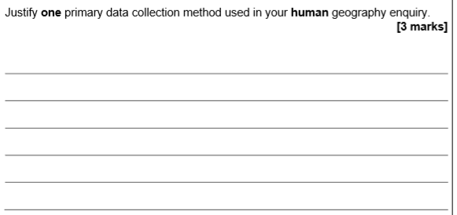
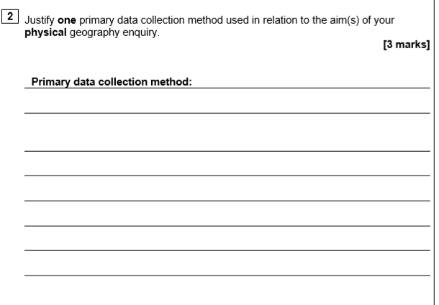
secondary
Human
(2 marks)

WWW:

EBI:

Improvement:

