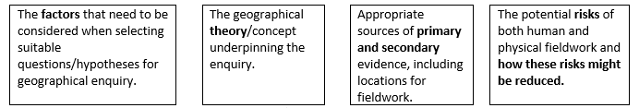
1. Choose a suitable question for the Geographical Enquiry.
- Extend ideas from the sentence starters.
- For completed answers highlight the point and the development.
- Try the questions without help.

Clearly geographical.
Low/manageable risk.
Appropriate scale.
Data available.
Manageable in terms of time.
Aware of:
weather (rainfall), river levels and flow, appropriate clothing/footwear. Unstable riverbanks. First aid kit in case of accidents. Mobile communications in case of an emergency.
Locations – OS maps used, land use maps.
Cound Brook - Carding Mill Valley – Shropshire Hills.
Stafford Town Centre, Staffordshire, West Midlands.
Primary data / Secondary data. SEE SHEET 2.
The Bradshaw Model – which describes how a river's characteristics vary between the upper course and lower course of a river.
Regeneration – A way to reduce social deprivation at the same time as making environmental improvements.

State the title of your fieldwork enquiry in which physical / human geography data were collected. | PHYSICAL  How do the characteristics of the Cound Brook change from site 1-6? (and does it match the Bradshaw model?) | HUMAN  Has the regeneration of the riverside area of Stafford been successful?
Explain why it was a suitable topic for a geographical enquiry. (2 marks)  P+D or P + P | The ……………………………………….. river allowed comparison of our results to the ………………………………. Model this allowed the Geographical theory to be tested.  Secondary data is available from previous years to compare Results to. The risk is ………………….. so safety has been considered. | The ………………………………………………. regeneration allowed ….. areas of Stafford to be compared. The  areas picked were manageable to walk in the time permitted (so the scale of the fieldwork was  manageable for access and time).
Explain the advantage(s) of the location(s) used for your fieldwork enquiry. (3 marks)  P+D x2 | Answers can relate to accessibility or safety.  As the Carding Mill Valley is a National Trust area, it is open to the public, this means ……………………  …………………………………………………………………………………………………………………………………………………………  The flow of the Cound Brook is …………………………………………. (below the knees), this means ………………………………………………………………………………………………………………………………………………………….  The river changes in a short space allowing 6 sites to be tested within walking distance. | Answers can relate to accessibility or safety.  The areas studied within Stafford are pedestrianised, this means ……………………………………………………….  ……………………………………………………………………………………………………………………………………………………………….  All the areas studied are within walking distance, with a range of sites available (regenerated, high  street, run down), this allowed the study to be completed within………………………………………………………..
Suggest one reason why risk assessment was important when planning your enquiry.  (2 marks) | Before carrying out our river study it was important to avoid water deeper than knee level, as this  would prevent you from ………………………………………………………………………………………………………………….  It was important to wear the correct footwear as wet rocks at the side of the river ………………………..  …………………………………………………………………………………………………………………………………………………………. | It was important for our urban study that we were aware of traffic risks. Areas were planned out to  prevent crossing any major roads, this reduced the risk of ………………………………………………………………..  As we had unsupervised access away from the teachers we had mobile phone numbers to allow ………………………………………………………..…………………………………………………………………………………………………

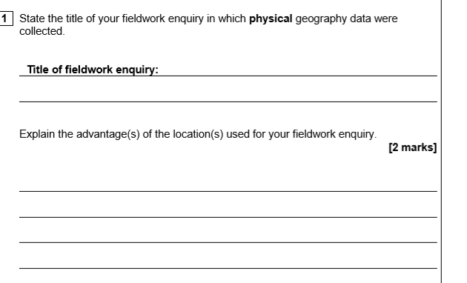
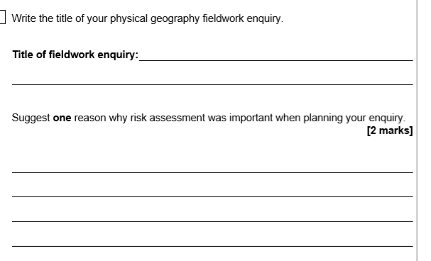
=

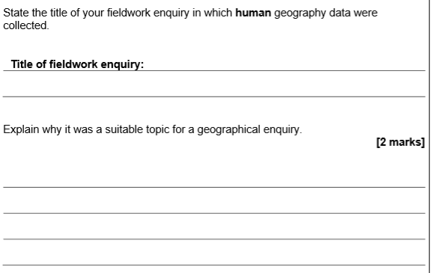
WWW:

EBI:

Improvement:

