Walton Baccalaureate
Physical Education
Year 7

Criteria for Baccalaureate recommendation in Y7 – complete compulsory criteria plus two others.

- Improve on three results in the fitness testing (September/April).

- Participate in a minimum of two sporting clubs/teams.

- Watch a sporting event (either in person or on the TV. This can be a past event). Review the experience giving a ‘highlights’ (photos/ video/ written commentary/ analysis).

- Watch a Walton High School fixture and publish a report that can be used on the Walton High School Facebook page (photos/ video/ written commentary/analysis).

- Compulsory criteria – Participate in a minimum of three online work-outs/ challenges (Facebook - Walton High School – PE Department).

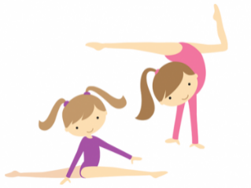
Walton Baccalaureate
Physical Education
Year 8

Criteria for Baccalaureate recommendation in Y8 – complete compulsory criteria plus two others.

- Participate in a minimum of three online work-outs/ challenges (Facebook - Walton High School – PE Department).

- Participate in a minimum of two sporting clubs/teams.

- Watch a sporting event (either in person or on the TV. This can be a past event). Review the experience giving a ‘highlights’ (photos/ video/ written commentary/ analysis)

- Watch a Walton High School fixture and publish a report that can be used on the Walton High School Facebook page (photos/ video/ written commentary/analysis).

- Compulsory criteria – Write an extended project about a sport of your choice. You should include a brief history, summary of rules/laws, scoring, positions, competitions etc.

