Acid rain & weathering

Your task is use the universal indicator paper to test the acidity of rain water in your area (think carefully about how you would do this)

Write a small report about:
- How you completed this task
- How many times you tested it
- What your results showed and what it tells you
- Compare this results to the one below and explain why you think this is different to yours

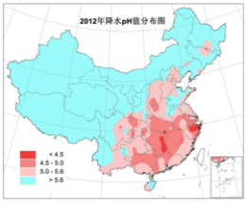

China – Some areas have a pH less than 4.5

