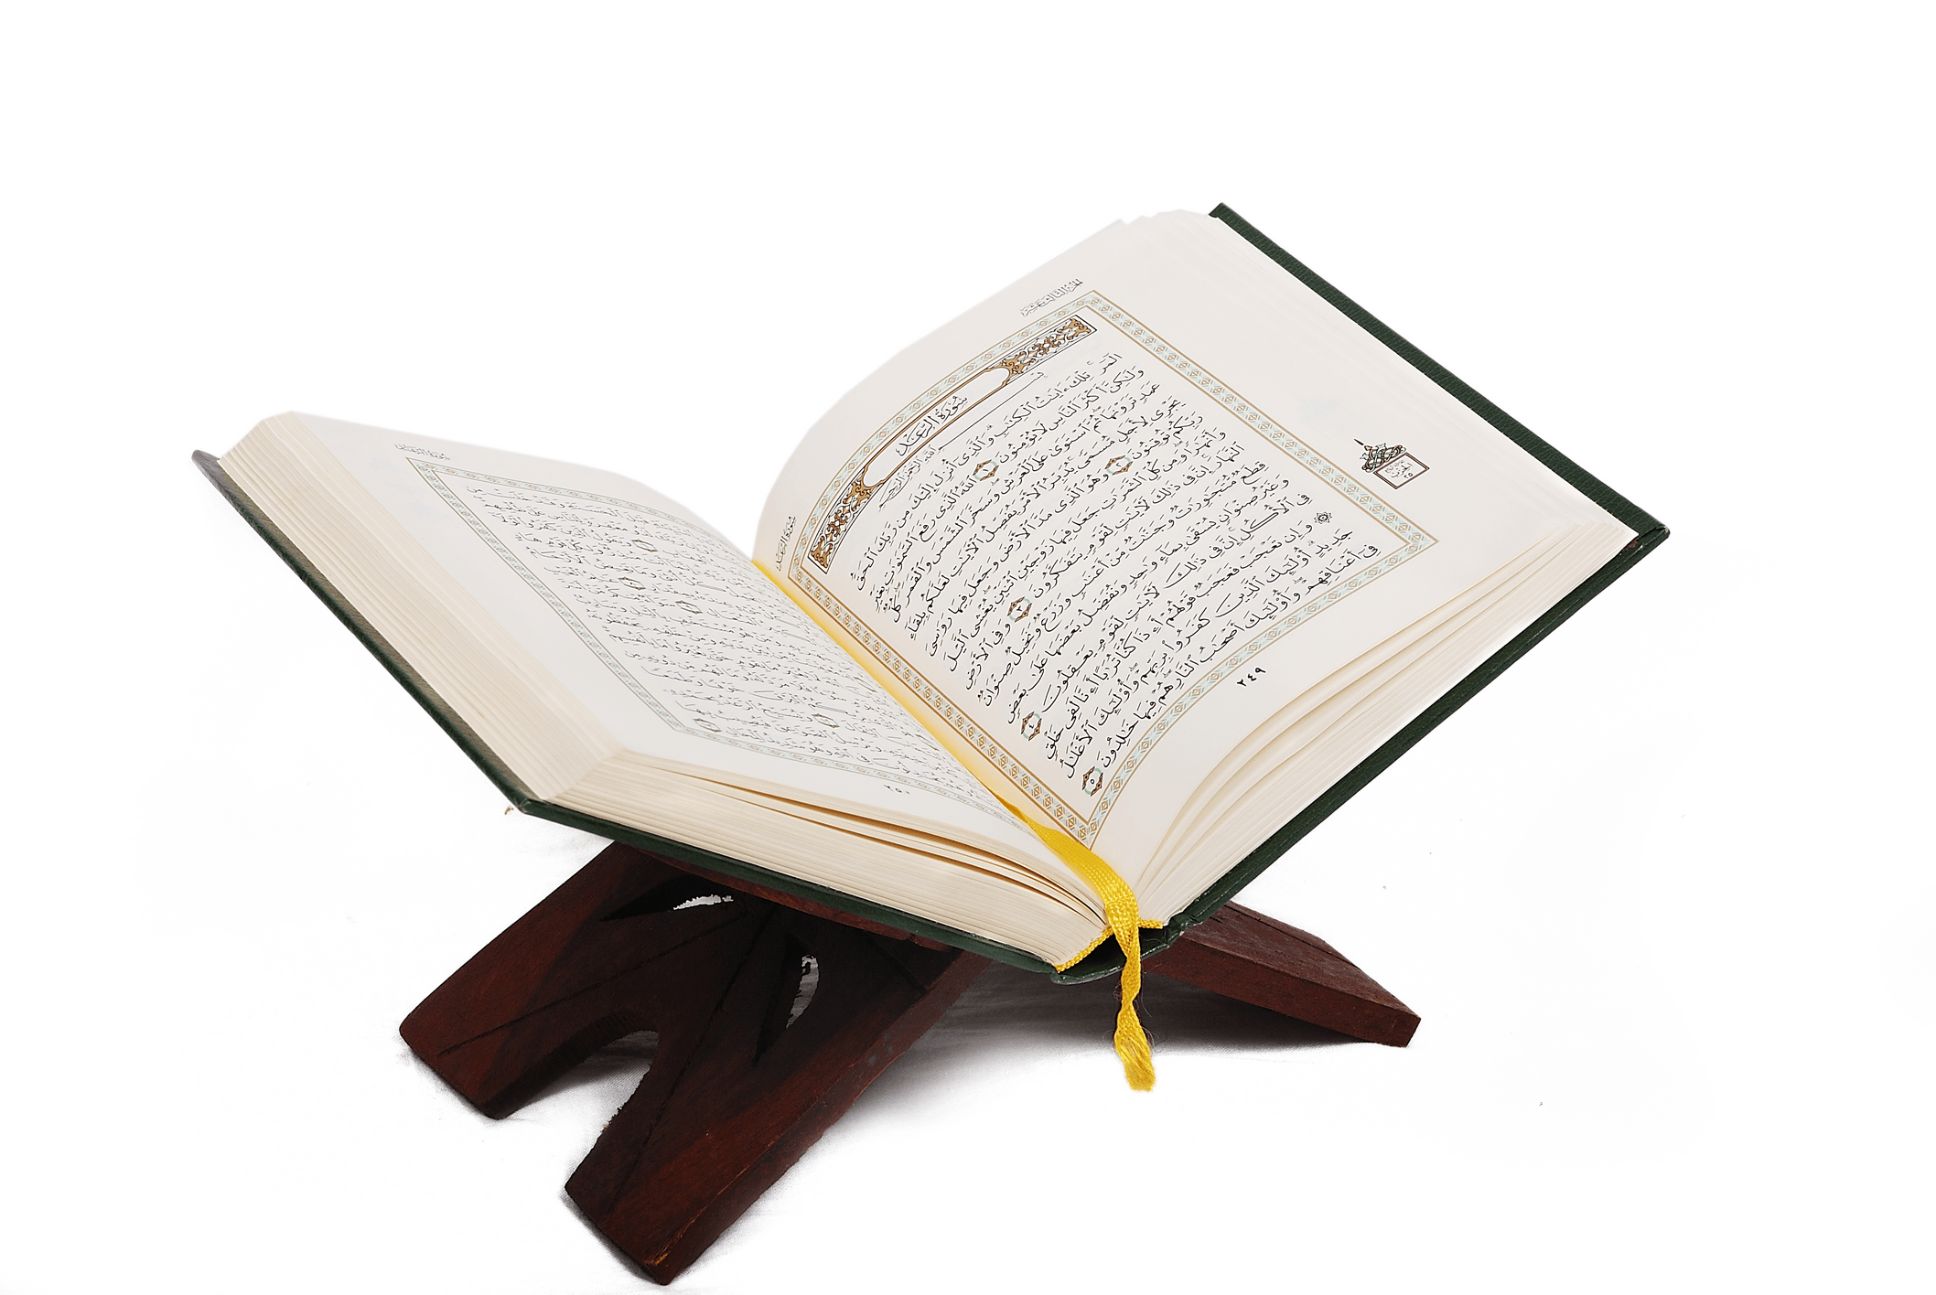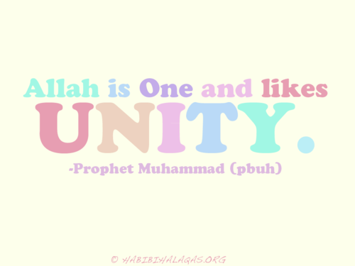



Image result for quote clipart

A**l-Fatihah, the opening**

The al-Fatihah is the first surah (chapter) in the Qur’an. It means   
‘the opening’ and many Muslims learn to recite it from memory in their   
daily prayers.

**The 99 names of God**

In Islam, God is not to be confused with any living creature; he is beyond all things and cannot be pictured as a physical being. God is outside of human understanding, but for Muslims he lies at the very centre of everything they think and do. So, how do Muslims ‘see’ God?

The Qur’an and the Hadith have many different ‘names’ for God, not as a person, but using words that describe his qualities and attributes. They use names like: King, Protector, Wise, Eternal, Light, etc. These are known as the 99 beautiful names of God. In fact, there are different lists of these names, recorded   
through different traditions of Muslims, but reciting these names   
has been a powerful form of prayer for Muslims throughout  
 the centuries.



“***Vision perceived Him not, but He perceives [all] vision;   
and He is the Subtle, the Acquainted***.” (Qur’an 6:103)

*“There is a polish for everything that takes away rust and the polish for the heart is the remembrance of God.”* (Hadith)

“***This is the Book about which there is no doubt, a guidance for those   
conscious of God***.” (Qur’an 2:2)

**The single most important belief in Islam is Tawhid, the oneness and   
unity of God. There is one God (Allah) who is the universal God of all   
humanity. Muslims believe that God is:**

* **Immanent: Close by**
* **Transcendent: Beyond all things; not limited by nature**
* **Omniscient: All-knowing**
* **Beneficent: Always kind; loving**
* **Merciful: Fair; God forgives if we are sorry**
* **Judge: on the last day, God will be our judge**
* **Creator: God is the beginning; he is the cause of all that   
  exists**

**In Shi’a Islam, there is an emphasis on Adalat, the Justice of God.   
Thisis one of the five roots of religion (Usul ad-Din). The Qur’an   
teaches that it was God “*who created the heavens and the   
earth*” and that “*He has power over all things*.” (46:33)**







Image result for heart clipart

Islam teaches that, long before the birth of the Prophet Muhammad,   
in pre-Islamic Arabia, there were groups of people known as hanifs. The hanifs   
rejected idol worship; they believed in one Supreme God, creator of the universe, the God of Ibrahim who had sent revelations to the prophets   
through the ages. It is said by some Muslims that Muhammad’s grandfather   
was a hanif and through him Muhammad learnt the practice of   
spending time alone in the desert to   
fast and pray.

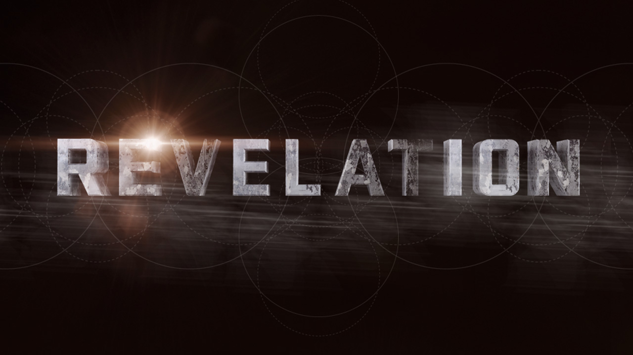

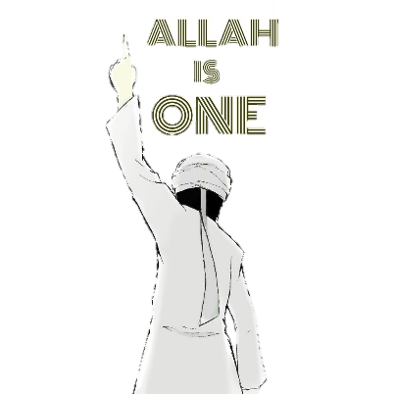

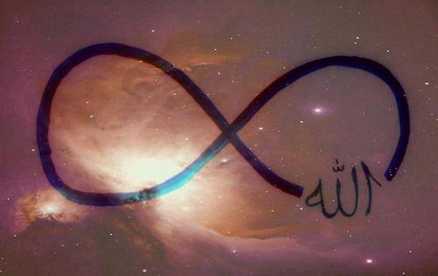



Islam is a **monotheistic** religion; it teaches that there is   
only one God. Muslims reject the Christian belief that Jesus is the   
Son of God. The passage, ‘***he begetteth not, nor is he begotten***’   
(Qur’an 112:3) makes it clear that God has no children and he is not the   
child of anyone.

**Sin of Shirk**

Islam warns of the sin of shirk (associating other beings or things with God).   
This is when a person worships something else other than God. There is one   
God and **there can be no pictures to represent him**. Muslims must worship   
the true God, not the image of him, created by human hands. The prophets   
bring the word of God, but they are only human; God is divine.

For most Muslims, it is a sin of ‘shirk’ to show a picture   
of the Prophet Muhammad.



**Fitrah: the need for God**

Islam teaches that we are all born with an instinctive need for God.   
This is called fitrah. It is the natural spirituality that connects us to our creator, making Muslims aware of God’s presence and drawing   
them to worship him. This is where our conscience comes from,   
helping us discern right from wrong.

**Taqwa: awareness of God**Taqwa is the desire for a personal with God. Muslims try to live   
in a state of taqwa, the awareness of God. The Qur’an refers to  
 taqwa as the highest quality of a Muslim, leading them to show   
worship and submission to God. Taqwa is often understood as   
a shield against wrongdoing; it allows Muslims to live as God   
would want, protecting them   
from evil.

**Revelation: God reveals his truth**

* **Bringing God’s message**: Islam teaches that God does not   
  communicate directly with humans, but instead he uses special   
  beings (humans and angels) to carry his message to us.
* **God’s duty to guide us**: Muslims believe that, because all humans have a duty to serve God, he must have shown us what his will is. As humans, we can only know what is truly right and wrong by understanding God’s laws. Since God is just, it makes sense to believe that he must have shown us the right path to follow.

**Revelation: God’s inspired truth**

* Revelation is the idea that **God has made known his special truth to humans**. Islam teaches that the prophets received God’s divinely inspired message, instructing humans how to live.
* God’s final and perfect message was given to the Prophet Muhammad, sent down to him over the last 23 years of his life. Each passage was memorised and recorded by his followers and then later written  
   down to form the Qur’an, the final revelation.

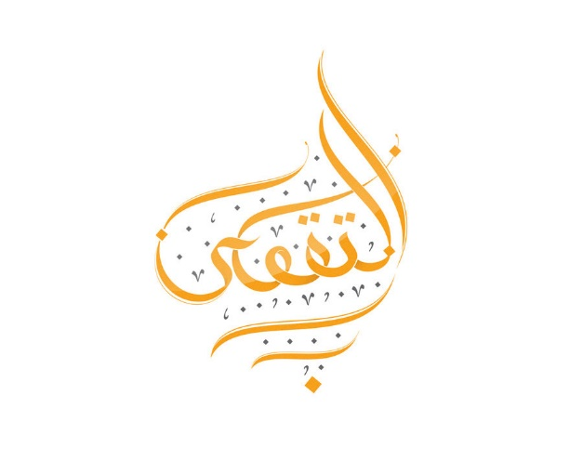



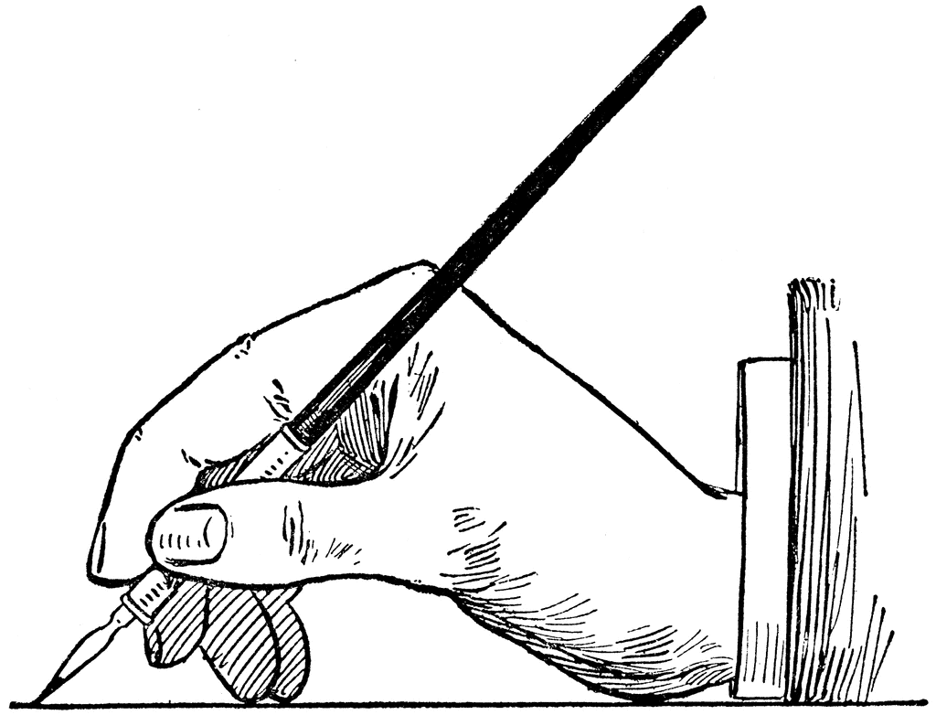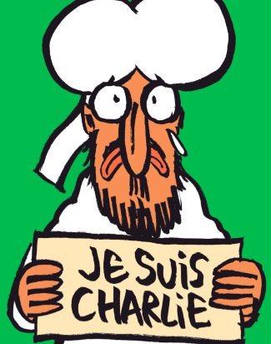

The publication, ‘Charlie Hebdo’ published cartoons of Muhammad. Many believed this to be hugely disrespectful to Muslim beliefs.

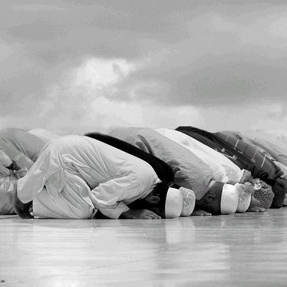





Image result for heart clipart