Year 7 Geography Homework menu – My World Investigated
Topic | Homework and description
W1 Your shopping habits  W2 How has shopping changed?  W3-4 Preparing for Lichfield  W5 Preparing for Lichfield – Designing a shop.  W6 onwards – Main assessment | Think about your shopping habits by keeping a record of what you buy over the next week and WHERE you buy it from. If you don’t buy much, maybe ask a member of your family to complete it with you!  Internet shopping is on the rise - from clothes shopping to grocery shopping! Your task is to investigate the advantages and disadvantages of using the Internet.  Think of ideas for yourself, but also ask your family and friends!  How will you present the results? It’s up to you!  A table? Spider diagrams? Pictures? Video?  Research facts ready for Lichfield. These can be used in your next assessment! For example…  What is the population of Lichfield?  What transport links are there to Lichfield?  How many car parking spaces are in Lichfield?  How many shops are in Lichfield town centre?  When are the market days? Where are the markets held?  Who is the biggest employer in Lichfield?  Design your shop ready for Lichfield. Follow the instructions below.  Your shop advert poster Check  - Name of your shop  - What does it sell? (Convenience / comparison?)  - Customer type?  - What factors do you require nearby for your shop to be successful?  Extended project over a number of weeks at the teacher’s discretion (deadlines will be given). Your homework task is to write a piece of work about the field visit to Lichfield. You must use the booklet to help you achieve your target level. A suggested plan for completion is given below…  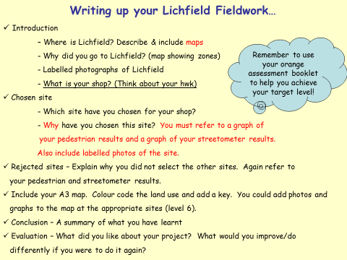  Students will be expected to bring in drafts each week of their sections/progress. They will not be fully marked each week, but they will be briefly assessed by peers and the teacher, and given feedback about where to extend when necessary.  The drafts will need to be looked after during the duration of the assessment and then either collated together in the form of a report or poster for the full peer assessment and to be handed in on the final deadline.

