RM Typerighter old

As he grew older, Muhammad began to feel troubled by the corruption and cruelty he saw in Makkah. He believed that   
the worship of idols by the people of Makkah was wrong and that there was really only one true God.

**Prophet Muhammad’s message**

The message brought to the people of Makkah was:

* There is **one true God**, Lord of goodness and power
* We need to **show thanks to God** through worship
* There will be a **judgement day** where God will judge   
  our lives

Many in Makkah did not receive this message well; he was ridiculed and insulted. However, some did follow him and   
they became known as ‘Muslims’.

RM Typerighter old

**Laylat-ul-Qadr**

Muhammad started to spend more time alone in prayer and solitude and one night, in the year 610CE, while he was praying in a cave near Makkah, he had an experience that would change his life. As he sat meditating, the Angel Jibril appeared before hum and ordered him to recite the words that had miraculously appeared before him. Muslims call this even Laylat-ul-Qadr, the Night of Power, and they remember it today on the 27th day of Ramadan. It is one of the holiest days of the Muslim year.

**The revelation of the holy Qur’an**

These revelations were to continue for the next 23 years, until Muhammad’s death. He did not always see the Angel Jibril; sometimes he heard a voice speaking to him; sometimes these revelations took place while he was in prayer, at other times when he was going about his everyday life.

***“Not once did I receive a revelation without thinking that my soul had been torn away.” (Hadith)***

Islam teaches that Muhammad is the last and the greatest prophet, send by God. He is a role model for Muslims because of the moral and prayerful way he lived his life. Unlike Jesus, he performed no miracles; he was born, lived and died an ordinary man, but Muslims see him as the perfect example of a human being.

**Who was Muhammad?**

Muhammad was born in Makkah (in Arabia) in 570CE, but by the age of 6 he had become an orphan. As he grew up, he gained a reputation for truthfulness and intelligence, working as a shepherd for his uncle. In his twenties he entered the service of a wealthy merchant named Khadijah and he so impressed her with his honesty and character that Khadijah proposed marriage. They married and had four daughters, and two sons (who sadly died in infancy).

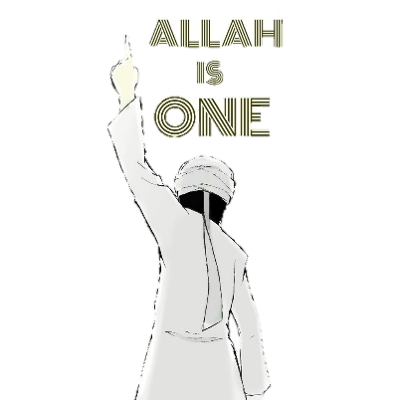





RM Typerighter old

RM Typerighter old

RM Typerighter old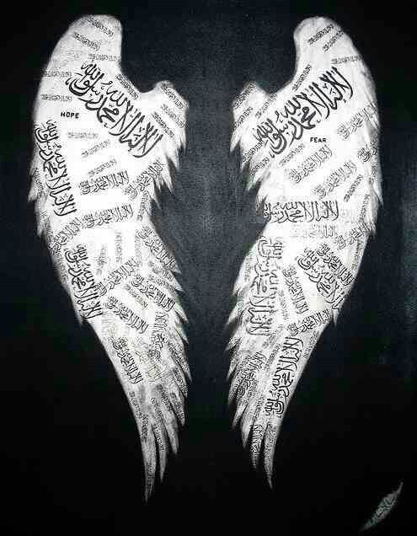

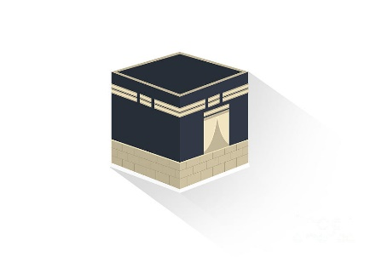RM Typerighter old

RM Typerighter old

RM Typerighter oldRM Typerighter old

RM Typerighter old

Not long after, while teaching in Makkah, Prophet Muhammad was approached by some pilgrims from **Yathrib**, a city some distance to the north. They were impressed with his message and invited him to visit, to judge their community disputes. He agreed and sent some of his followers ahead of him.

Now, as he planned to leave, it became clear that his life was in danger; there were people plotting to kill him. **Ali** (Muhammad’s cousin and son-in-law) insisted in staying behind in Makkah, to act as a decoy, whilst Muhammad made the journey. The migration of Muhammad from Makkah to Yathrib is known as the **Hijrah**. It marks the start of the Muslim calendar.

In the years following his first revelation, Prophet Muhammad gained some followers in Makkah, but his ideas also angered many. Makkah was a centre for pagan pilgrims who came to worship the idols in the Ka’ba, bringing great wealth into the city. Muhammad began preaching openly that the worship of idols offends God and that these idols were no more than useless bits of wood and stone.

His message, that God is merciful, but that there will also be a Day of Judgement caused many to turn against him and threaten violence. For nearly ten years Prophet Muhammad struggled to gain converts in Makkah, with little success and then tragedy struck: two of his closest supporters, his uncle and his wife Khadijah, died. This was a devastating blow.



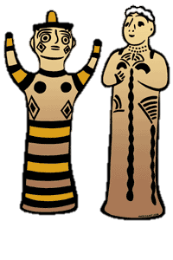



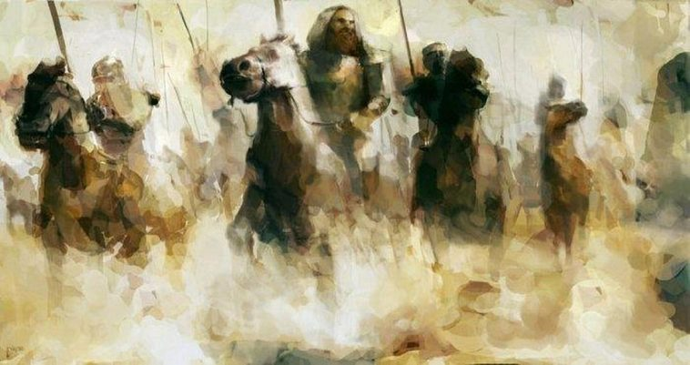RM Typerighter old

Prophet Muhammad was welcomed into Yathrib, where he came to be seen not just as a prophet, but also as a political leader and military commander. He became the city’s ruler and it was renamed **Madinah** (City of the Prophet). For the next ten years he worked to unite the different communities. There are a number of Jewish tribes in Madinah and he had expected them to become Muslims. However, many rejected Prophet Muhammad’s belief that the revelations he received were from the same God that they worshipped. They refused to believe that they should now turn towards Makkah to pray (instead of Jerusalem) and that they should fast during Ramadan. Some of these Jewish tribes in Madinah began to plot against Muhammad and so he was forced to expel them from the city. By 630CE he has gained enough support across Arabia to march on Makkah with an army of 10,000 men. Faced with this overwhelming force, the rulers of the city conceded defeat and opened the gates. **Makkah was taken without the shedding of a drop of blood** and the Ka’ba was cleansed of idols and re-dedicated to Allah.

RM Typerighter old

**Muhammad returns to Makkah triumphant**

* In 630CE Muhammad and his followers were able to return to Makkah, where they   
  forgave their enemies and established Islam as a permanent religion. Muhammad   
  was not accepted as the final and true prophet of God. He continued to lead his   
  community until his death in 632CE.
* “***I leave behind me two things, the Qur’an and the example of my life (the Sunnah).   
  If you follow these you will not fail***.” (Muhammad’s final sermon in Makkah)





