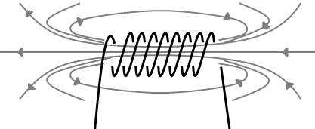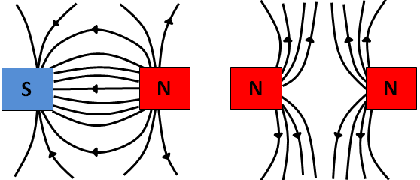

All of the AQA science revision sheets at www.tes.com/teaching-resources/shop/teachsci1

North  
pole

South  
pole

**Solenoids**Creating a coil from a wire increases the strength of the magnetic field. The coil is called a solenoid.  
The magnetic field is strong and uniform.  
Outside the coil, it acts like a bar magnet with a north and south pole.

Make a fist with your right hand and hold your thumb up in the direction of the current. Your fingers pint in the direction of the magnetic field.

Wrapping the wire around an iron core creates an induced magnet and increases the strength of the solenoid.  
If the current is stopped the magnetic field disappears. A solenoid with an iron core is called an **electromagnet** – it can be turned on and off.

* Point your **f**irst finger in the direction of the magnetic **f**ield.
* Point your se**c**ond finger in the direction of the **c**urrent.
* Your thu**m**b points in the direction of the force (**m**otion).

**Electric Motors**Use this method to find the direction of the force in a motor:

A DC motor works by passing a current through a wire loop on a spindle between two magnets. The spindle allows the loop to rotate.   
The direction of the motor can be reversed by reversing the current.  
Increasing the current, adding more turns to the coil or using stronger magnets will increase the speed of the motor.

Length (m)

Current (A)

Magnetic flux density (T, tesla)

$$F=BIl$$

Force (N)

* Size of the current
* Length of the wire in the magnetic field
* Magnetic flux density (the number of field lines/strength of magnet)

**Motor Effect**If a wire carrying a current is placed in a magnetic field the magnet and wire will exert a force on each other. The maximum force is felt if the wire is at 90° to the magnet.  
The force on the wire depends on:

**Electromagnetism**A current flowing through a wire creates a magnetic field around the wire in concentric circles.  
A larger current will produce a stronger field and at a greater distance from the wire.

**Permanent or Induced Magnets  
Permanent magnets** produce their own magnetic field.  
**Induced magnets** are made from magnetic materials (eg. iron, steel, nickel, cobalt). They turn into a magnet when held in a magnetic field. Magnetic materials will always be **attracted** to a magnet.

**Magnetic Fields**Magnets have a north and south pole. They produce magnetic fields – a non-contact force felt by other magnets or magnetic materials.

Field lines always go from north to south pole. They show the way they would act on a north pole if it was held in the field.

A **compass** is a small bar magnet. When held in a magnetic field the needle will point north.

Like poles  
repel

Opposite  
poles  
attract

**Magnets**