Year Group Term | Autumn | Spring | Summer
Year 7  Possible themes:  Natural forms- leaves, shells, pods, flowers  Food- cakes, parties, table settings,  Cultures- African, Indian, Aboriginal, Egyptian, Oriental, Islamic  Sculpture- Figurative, abstract  Environment- landscape, locality, urban, rural, community | Natural forms  Shells, leaves, pods,  Drawing techniques including line, tone and texture. Wire string  Research an Artist – Karl Blossfeldt, Sarah Lugg, Georgia O’Keeffe etc  Assessment 1 – Drawing test - Natural forms | Food in Art  Cakes, food  Drawing, painting and printmaking.  Colour and pattern.  Research the artists Sheila Marshal etc  Produce a textile stitched piece either a hanging or 3D piece  Assessment 2 – Artists research page | Cultural Art  African Art  Collage and 3D, clay, card etc  Research a culture, African Art  Make a 3D piece – shield, pot etc  Assessment 3 – Final piece for Unit of work
Year 8  Possible themes:  Man made- clothing, utensils, machine parts, keys, shoes  Recycled- reused, everyday objects  Animal, insect, sea life- Butterflies, Fish, animal skins, scales.  Locality- pattern, colour, cultural, maps | Locaility  Students look at the work of Aboriginal artists in Australia. Make links with map making, animals and local landscapes e.g. the chase, Walton village, Stafford  Research the artists Aboriginal Art, Local artist Lisa Henderson etc  Produce work from landscape  Assessment 1 – Drawing test - Masks | Man Made/ Recycled  Students explore man made items such as clothing, utensils, machine parts, keys, shoes.  Research an Artist – Jennifer Collier, Jim Dine etc  Final piece – clothing, large object  Assessment 2 – Artists research page | Animation  Students plan and make a stop frame animation. Experiments with planning, flick books, storyboards.  Research an Artist – Aardman, animation art.  Final piece – stop frame animation  Assessment 3 – Final piece for Unit of work
Year 9  Possible themes:  Man made- Keys, musical instruments, machine par  ts, shoes, toys, sweets Empathy  Barbara Kruger, issue based: Political and social power, gender, identity, cultural stereotypes, domestic violence  Word and image  Graffitti, lettering, graphics, sweets, packaging, pop art  Magazine, Delal Fares | Sweets/ Toys  Students will explore drawing and painting techniques.  Research an artist -Sarah Graham, Jeremy Dickinson, etc  produce large scale work in paint and colour  Assessment 1 – Drawing test - Shoes | Empathy  Students will explore social, political and emotional issues.  Research the artist Barbara Kruger and Rankin (photographer) etc  Produce work in photography, drawing, design, and painting and drawing.  Assessment 2 – Artists research page | Word and Image  Students will produce work on the theme of Word and image, focussing on self and hobbies.  Research the Artists David Carson, Del Fares, Teesha Moore, Tracy Moore etc  Produce a self-portrait (inside and out) and a magazine on a chosen topic.  Assessment 3 – Final piece for Unit of work
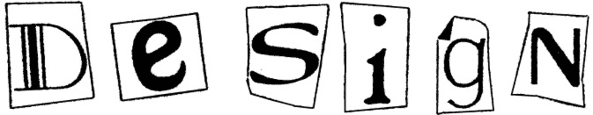
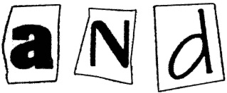
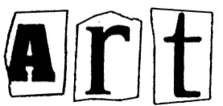
These themes change and others we use are: Art in the environment, The built environment, Insects, Utensils, Animation etc

