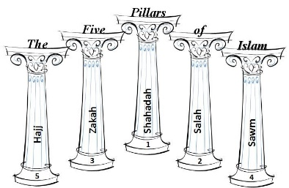Old Alpha AlphaOld Alpha Alpha

**The greater jihad** is a spiritual struggle with oneself. It is the desire   
and commitment to live the perfect Muslim life. This includes performing   
the Five Pillars with devotion, practising the path set out by Muhammad,   
seeking justice and fairness for all and rising above one’s own greed   
and selfishness.

**The need to control desires**Islam teaches than Muslims need to control their own desires and behaviour, to follow the Five Pillars and live a life that is pleasing to God. This will ensure that when the last   
day comes, and they are brought to judgement by God, they will be worthy to   
receive God’s favour and thus to enter paradise.

**Respect for the beliefs of others**The Qur’an encourages Muslims to be tolerant and respectful towards the beliefs of others. ‘To you be your religion, and to me mine’ (109:6) Muslims should live in   
peace and harmony in society, celebrating differences and   
obeying the law.

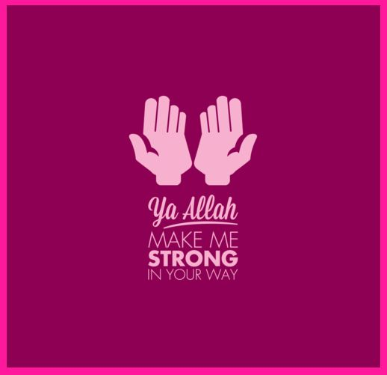

Jihad is the struggle to live according to God’s laws. It is one of the   
most misunderstood worlds in Islam, because to many people ‘jihad’  
means ‘holy war’, but in fact it has a deeper meaning than this. Jihad   
actually means ‘directed struggle’. This can mean striving to serve   
God, making an effort to live a moral life or actively trying to live in peace.

**The greater jihad and the lesser jihad**

Muslims make a distinction between the greater jihad (the personal struggle for right) and the lesser jihad (the desire to remove evil from society). It is the duty of all Muslims to try to remove evil from society, but you can only fight for justice in the world when you   
have truly removed the evil from your own life.

Prophet Muhammad said that the supreme jihad is   
against oneself.

**The battle against laziness**There is a prayer of Prophet Muhammad which says: “God, I seek thy protection   
against helplessness and laziness, and against cowardice…and miserliness.” This   
describes the greater jihad. It is the commitment to make the effort to be a better  
 person and live as God has instructed.

The greater jihad is the spiritual fight against the tendency to be lazy: to get up for   
prayers before dawn, to only eat food that is halal (permitted), to show kindness and generosity towards other people.

**Encourage what is right**The Qur’an urges Muslims to ‘encourage what is right (ma’ruf), and forbid what is wrong’ (3:104). This process is partly about removing evil from yourself, but also about making the world a better place. Prophet Muhammad says, “Whoever amongst you sees   
an evil, he must change it with his hand. If he is not able to do so, then   
with his tongue. And if he is not able to do so, then with his heart,   
and that is the weakest form of faith.”   
(Hadith)



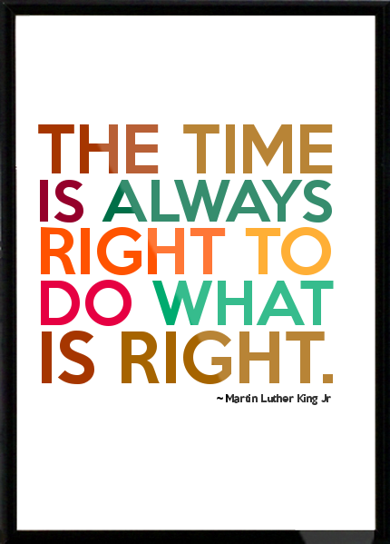







There are certain circumstances in which Islam   
accepts that force needs to be used, but only ever   
in self-defence. While the greater jihad is the personal struggle against sin, the lesser jihad or holy was is the struggle to remove   
evil from society. This involves the whole community, rather than the individual, and there are strict rules for the use of force in   
jihad. **“To those against whom war is made, permission is   
given to fight, because they are wronged.”**   
(Qur’an 22:39)

Old Alpha AlphaOld Alpha Alpha Regular

The Muslim Council of Britain (MCB) speaks on   
behalf of British Muslims. They have strongly   
condemned the actions of IS, saying they are horrified   
by the group’s “twisted message” and barbarous behaviour. The #notinmyname hashtag has been widely used to   
make it clear that IS does not represent the view of   
British Muslims.



Old Alpha Alpha

Old Alpha Alpha

**The origin of lesser jihad**The concept of lesser jihad arose during the Prophet Muhammad’s lifetime, when he   
gave his faithful followers authorisation to fight. Muhammad’s enemies in Makkah planned to wipe out all the Muslims and do they believed that there was no choice but to engage in conflict. ***“Permission [to fight] has been given to those who are being fought, because they were wronged.   
And indeed, God is competant to give them victory."*** (Qur’an 22:39)This passage records the permission given by God for the Muslims to defenf themselves against their enemies. Some argue that war with such a pure motive (to establish the principles of religious freedom) is a true jihad. ***“Fight in the way of God whose who fight against you but do not   
transgress. Indeed, God does not like   
transgressors.”*** (Qur’an 2:190)

**Today**, most Muslims agree that a holy war can only be called   
against an aggressor that threatens Islam. Some Islamic extremist groups argue that   
the attack on the World Trade Centre (the Twin Towers) in New York, on September   
11 2001, commanded by Osama Bin Laden, was an act of jihad. However, moderate   
Muslims reject this idea, arguing that this attack was an aggressive act, which targeted  
 innocent civilians and so fails the test set by the Qur’an.

**The rise of jihadist groups:** There are a number of groups who have labelled themselves as  
 jihadists in recent years (for example, Al-Qaeda, Boko Haram, Islamic State/Daesh). They   
 are prepared to use violence in order to create an Islamic State that would be   
 governed in accordance with Islamic (Shari’ah) law. Western governments regard   
 these groups as terrorist organisations and moderate Muslims   
 reject this form of extreme Islam.

**Jihad must never be aggressive**The Qur’an lays down the condition that the Muslims must not be the first to attack;   
a war of aggression is prohibited. However, if it can be agreed that a war is a ‘jihad’, then it   
is a duty to fight back, but only against those who are attacking you, never to kill civilians.  
**Who can declare jihad**?  
Muslim law is clear that jihad can only be declared by a Muslim leader who is holy and pure and   
who has the support of the whole Muslim community. Some Muslim communities do believe  
 their leaders are able to declare jihad. However many Muslims today say that it is difficult to   
see how these conditions for jihad could be met, because there is no one, indisputable Muslim  
 ruler who would be eligible to declare it.

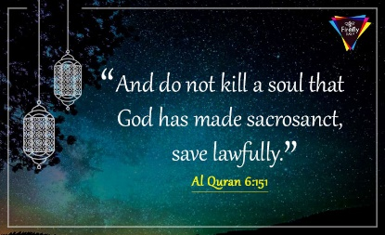



Old Alpha Alpha

***“The greatest jihad is to battle your own soul, to fight the evil within yourself”***   
– Prophet Muhammad