HIVNotRetro Regular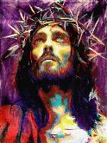

**Christians believe that Jesus was:**

1. God incarnated (God made human)
2. Not conceived through sexual intercourse, but born to the Virgin Mary through the power of the Holy Spirit. This was foretold by an angel. The   
   **Bible** says, “*Do not be afraid, Mary; you have found favour with God. You   
   will conceive and give birth to a son, and you are to call him Jesus. He will be   
   great and be called the Son of the most High. The Lord God will give him   
   the throne of his father, David, and he will reign over Jacob’s descendants forever; his kingdom will never end.*”
3. The Son of God: “*The Word became flesh and made his dwelling among us. We have seen his glory, the glory of the one and only Son, who came   
   from the Father, full of grace and truth*.”

**Four important events in Jesus’ life:** The Incarnation (God becomes man)**;** The Crucifixion and death of Jesus**;** Resurrection**;** Ascension to heaven

Some Christians believe that Jesus’ life and death is an act of atonement for the sins   
of the world and that salvation is offered to all those who believe this. All of these events are recorded in the Gospels.

**How was Jesus divine?**

For Christians there are many events or miracles from the life of Jesus which provide evidence that he was divine, such as:

1. The miracle of the virgin birth
2. The voice of God at the Baptism of Jesus
3. Jesus’ ability to perform miracles
4. The transfiguration of Jesus, when he was transformed in front  
   of some of his apostles and shone with glorious light
5. The resurrection of Jesus

Jesus’ teachings brought him into conflict with the Jewish   
authorities, who accused him of blasphemy because he claimed to be able to   
forgive sin. His followers believed he was the Messiah, which led to his arrest and execution as the authorities believed that Jesus was claiming to be King – this was treason. The Romans executed people by crucifixion because it ensured that criminals died in agony. It was a powerful way to intimidate the civilians. Jesus was crucified on Good Friday. A crown of thorns was put on Jesus’ head, to mock him as ‘King of the Jews’. Jesus suffered like any other human being as he is truly God and truly human. Jesus participates in the suffering of humanity. This is important because it shows that God understands human suffering.

**Main points of the crucifixion:**

Jesus is executed by the Romans; the soldiers mock Jesus and put a crown of   
thorns on him; He is crucified at a place called Golgotha; two criminals   
are crucified with him; Jesus is mocked by people in the crowd; Jesus   
prays while on the cross; Jesus dies on the cross; a darkness   
came over the land at   
Jesus’ death







Related imageRelated imageRelated image

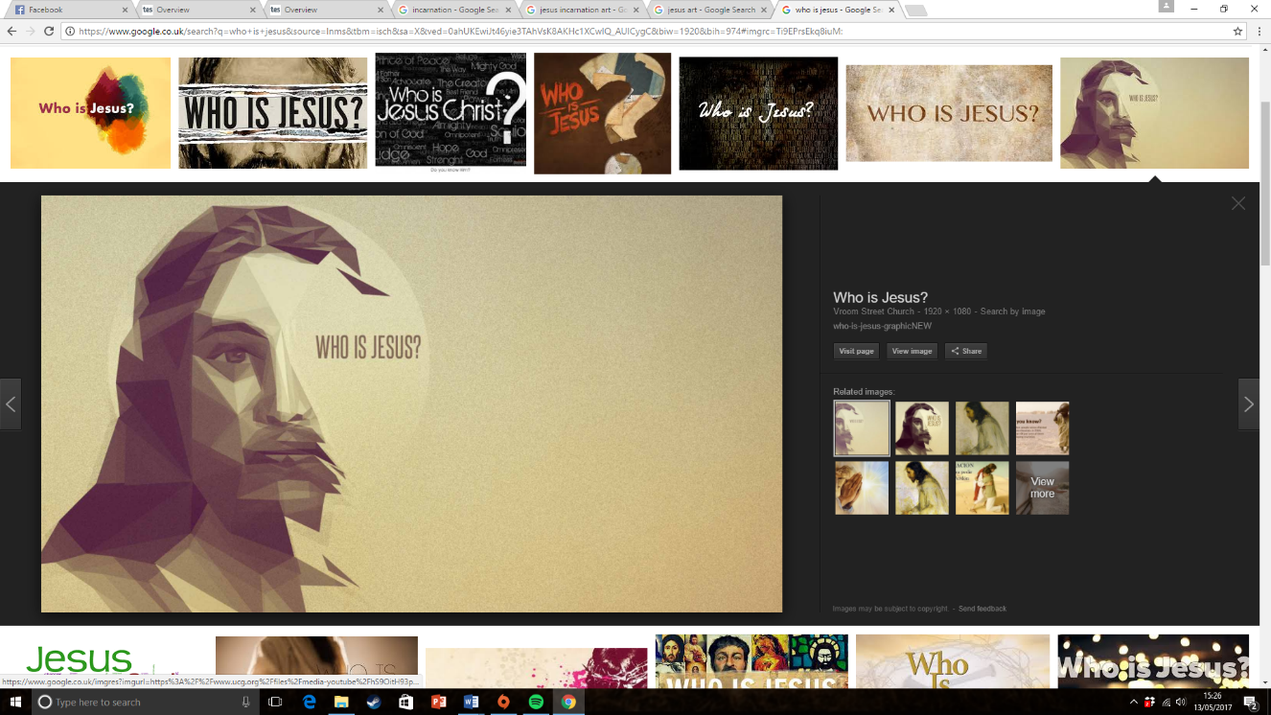

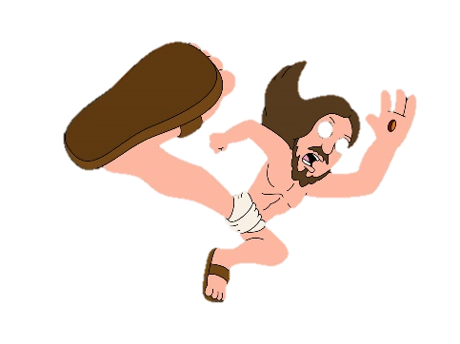HIVNotRetro Regular

HIVNotRetro Regular

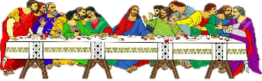





The Last Supper: Matthew 26:26-29

“While they were eating, Jesus took bread, and when he had given thanks, he   
broke it and gave it to his disciples, saying, ‘Take and eat; this is my body.’ Then  
he took a cup and when he had given thanks, he gave it to them, saying, ‘Drink from   
it, all of you. This is my blood of the covenant, which is poured out for many for   
the forgiveness of sins. I tell you, I will not drink from this fruit of the vine from now   
on until that day when I drink it new with you in my Father’s kingdom.”  
At the Last Supper, Jesus is celebrating the Jewish festival of Passover with his disciples,   
but he gives the meal a new importance.

1. **The bread represents Jesus’ body**
2. **The wine represents Jesus’ blood**
3. Jesus predicts his death on the cross and says that because of his sacrifice, the sin of humans will be forgiven.
4. Christians share the bread and wine in worship today.

5. Christians are promised eternal life in heaven because   
of the sacrifice of the Messiah or ’Chosen One’



**After Jesus rose from the dead:**

* Jesus appeared to the disciples
* Jesus appeared to other people
* Jesus ascended (rose) to his Father in heaven

There are different interpretations of this. Some Christians believe that Jesus physically ascended into heaven. The Gospels record these events in similar, but not identical, ways.

The ascension is important because it marks the end to the presence   
of Jesus on earth in a physical way. Christians believe that Jesus’   
Spirit is now at work in the world.

**Incarnation:** This is God becoming human in the form of Jesus. **Resurrection:** The belief that Jesus rose from the dead on   
Easter Sunday, conquering death.

1. Jesus death is an act of atonement
2. The Fall (Adam and Eve) produced sin in the world. New   
   humans are born with ‘original sin’ because of this
3. The sin people commit in their daily lives takes people further   
   away from God
4. Jesus was sent to earth to repair the broken relationship with God
5. Jesus paid the ‘price’ for our atonement
6. Because of Jesus’ sacrifice, humans can receive salvation, meaning that they can live on for eternity with God in heaven
7. Before Jesus, Jews sacrificed animals to ‘atone’ for their sins
8. Jesus became the ‘sacrificial lamb’ and took the sins of the world upon himself. It was no longer required to sacrifice animals

The resurrection is essential to the Christian faith. It is the greatest miracle recorded in the  
 New Testament and is evidence that Jesus was God. All Gospels agree that on the Sunday   
following Jesus’ crucifixion, some of Jesus’ followers went to his tomb. They found that   
the stone covering the entrance to the tomb had been rolled away and Jesus’   
body was not inside.



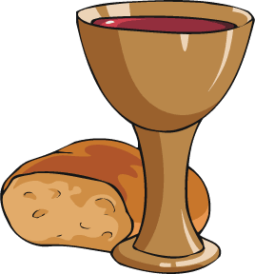





HIVNotRetro Regular

HIVNotRetro Regular

