

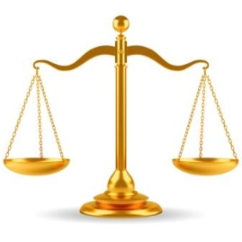



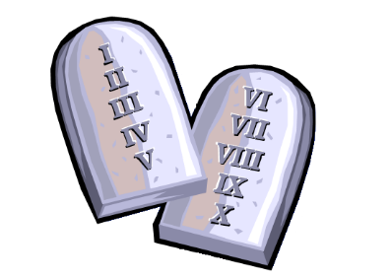



The Qur’an is believed to be a sacred text,   
perfectly inspired by God and thus free from any mistakes or distortion. However, Muslims do believe that God revealed his laws in stages, through the prophets. Muslims have a respect for all previous scriptures from the messengers of   
God, but they see the Qur’an as the   
completion of the   
earlier books.

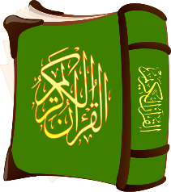





Muslims believe that God has sent messages to set   
out the laws and moral codes by which humanity should live. These communications are called revelations and the most significant among them is the Qur’an, God’s final written word.



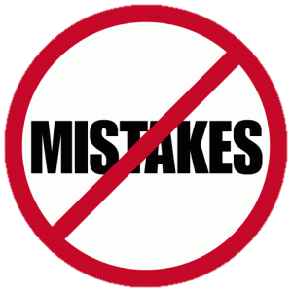

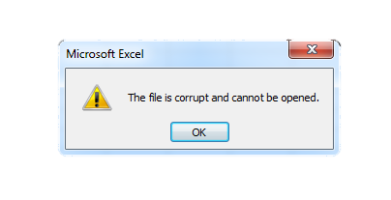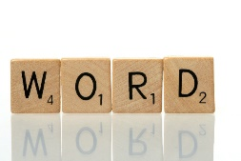



The Qur’an names four other holy books, known in Arabic as kutub.   
These are from the Jewish and Christian traditions and, according to Islam, in their   
original form, they were true revelations from God. However, because they were   
not properly written down or preserved, they are now believed to be corrupted. So,   
unlike the perfect Qur’an, they cannot be trusted as the true word of God.

1. **Sahifah**: The Scrolls of Ibrahim, now lost  
2.**Tawrat** (Torah): the revelation given to Musa (Moses)  
3.**Zabur** (Psalms): given to Dawud (David)  
4.**Injil** (Gospel): the teaching given to Isa (Jesus)

There are collections of thousands of Muhammad’s sayings, called hadiths, which   
form part of what Muslims call the Hadith. These are not revelations, because they are   
 the words of the prophet, not the words of God. However, they have enormous   
 significance for Muslims because the whole of Muhammad’s life is considered to  
 be a ‘living Qur’an’. As his third wife, Aisha, said of him: ‘His way of life   
 is the Qur’an.’

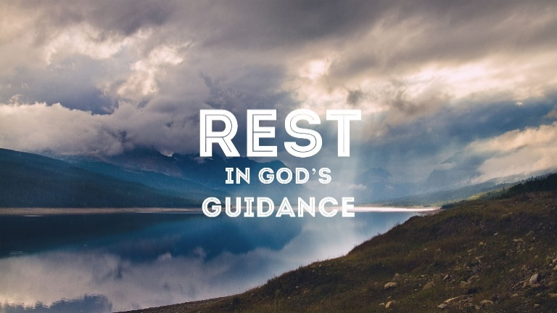

Muslims believe that the Qur’an is the direct and perfect word of God. Sunni Muslims say that it has always existed and is with God in heaven, written in Arabic on a tablet of stone. The Qur’an introduces itself as being ‘the guidance for the worlds’ (3:96) and Muslims believe that God has sent down this guidance in the form of a book to give a solution to any human problem.

Muslims respect and honour the Qur’an and use it as a   
guide for their lives. It teaches them how to worship, how   
to treat other people and how to live good lives. They learn   
it by heart in Arabic, reading and reciting it daily; they take   
immense care in writing it out; they allow it to   
guide every action   
and thought.

