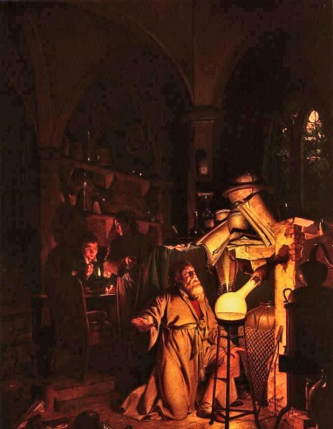
Find an article on Alchemists and use it to answer the following questions in as much detail as you can. You must use your own words:
Who were the Alchemists?
What period in history are Alchemists involved in?
What did they aim to do?

Find an article on Alchemists and use it to answer the following questions in as much detail as you can. You must use your own words:
Who were the Alchemists?
What period in history are Alchemists involved in?
What did they aim to do?

Find an article on Alchemists and use it to answer the following questions in as much detail as you can. You must use your own words:
Who were the Alchemists?
What period in history are Alchemists involved in?
What did they aim to do?

