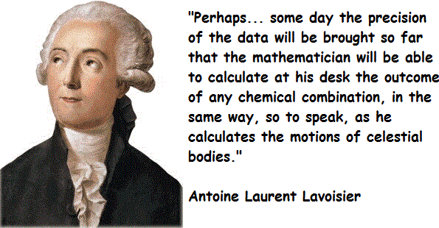 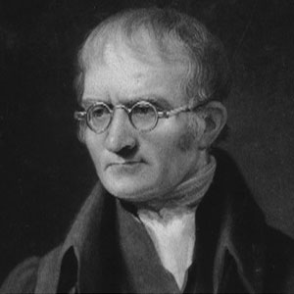

John Dalton

Antoine-Laurent de Lavoisier

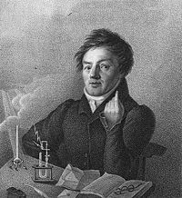 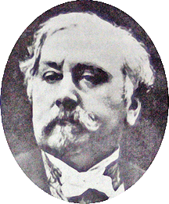 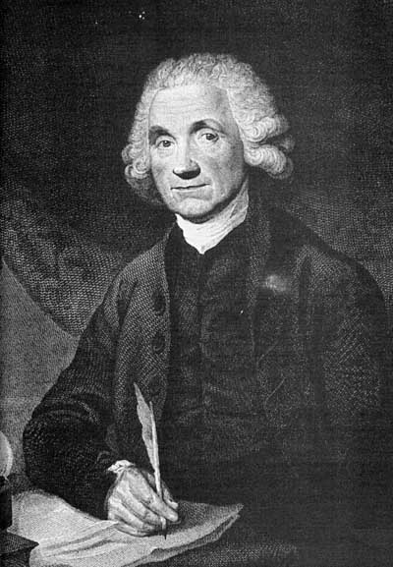

Johann Wolfgang Döbereiner

Alexandre-Emile Béguyer de Chancourtois

Joseph Priestley

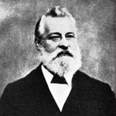 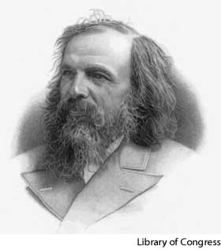 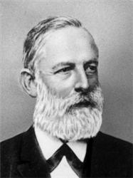

John Newlands

Lothar Meyer

Dmitri Mendeleev

**Your task is to design a timeline or poster to inform Year 8 pupils about the history of the Periodic Table.**

In your timeline or poster you must include:

* The **names** and **dates** of the main scientists involved in the development of the Periodic Table (use the hints of the names of the scientists used above)
* Details on how each scientists arranged the Periodic Table (write about two sentences for each scientists