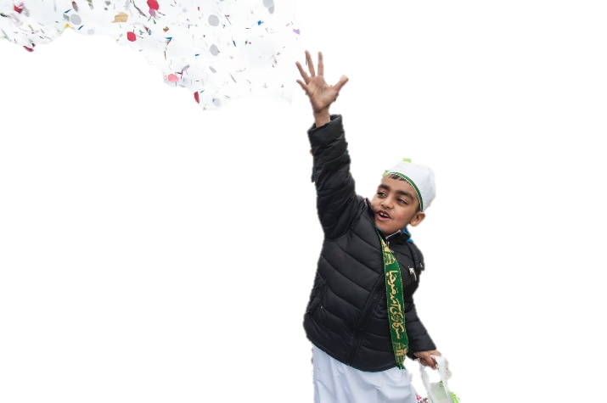four potatoes farm Regular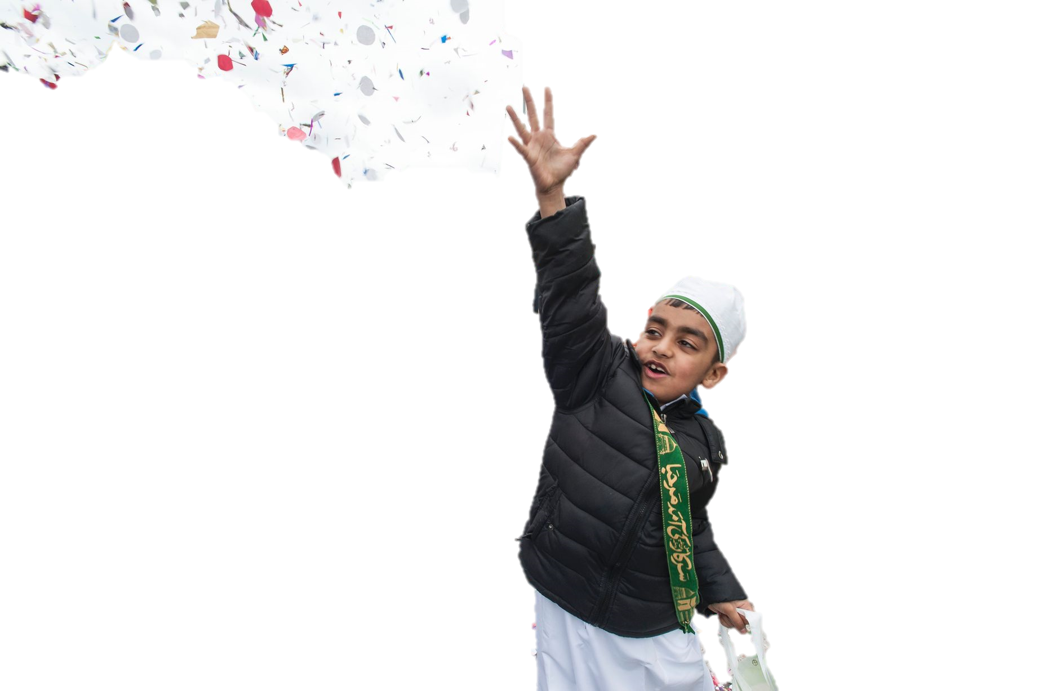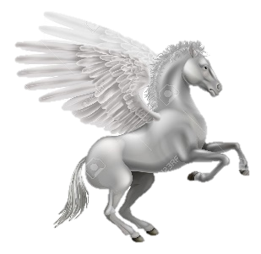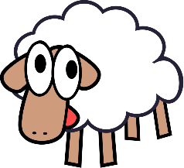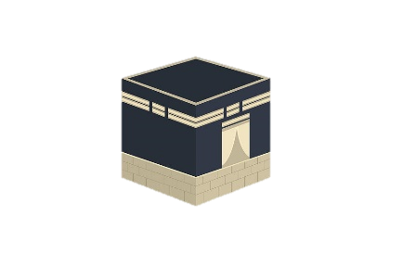

**(Birth of the Prophet)**

Mawlid an-Nabi is the celebration of the birth of the Prophet Muhammad. It is a public holiday in many countries. In Britain, Muslims celebrate this day with joyful processions through   
the streets, chanting stories in praise of his life.

**(Night of Power)**  
Laylat-ul-Qadr is one of the holiest days in the Muslim   
calendar, marking tha date when the Qur’an was first   
revealed to the Prophet Muhammad. Islamic tradition is   
not certain of the exact day, so this event is remembered throughout the last ten days of the month of Ramadan. During this time, Muslims may stay up all night, reciting the Qur’an, praying and remembering God’s mercy and forgiveness.

Laylay-ul-Miraj remembers Prophet Muhammad’s miraculous journey on a winged horse to Jerusalem and then up through the heavens into the presence of God. Today, Muslims commemorate these events at the mosque by saying particular prayers and at home by telling the story to their children and reciting special night-time prayers.  
  
  
Laylat-ul-Bara’at is the night of the full moon in the month before Ramadan. This is the night on which Muhammad used to begin his preparations for Ramadan and many Muslims stay up all night reciting the Qur’an.  
  
  
Muharram is the first month of the Islamic calendar and it remembers the Hijrah, when Muhammad and his followers fled from Makkah, to establish the first Muslim community in Madinah. Sunnis fast on the tenth day of Muharram. Shi’as observe Muharram as the month when Husayn (Prophet Muhammad’s grandson) was martyred and so they refrain from joyous events in his memory.



All Muslim festivals have special significance, often relating to events or stories from Islamic history. However, festivals in   
Islam are not just moments of joy and happiness, they are also occasions to worship and remember the presence of God.

Islam has relatively few holidays and Muslim festivals are   
usually quite restrained events. Islam is a religion of   
moderation: the Qur’an forbids indulgence and extravagance and Muslims are instructed not to eat so much as to fill the whole stomach. Prophet Muhammad encouraged his followers not to drink water greedily, in one gulp, but to pause and sip. The Prophet Muhammad said: “He is not a Muslim who goes to bed with a full stomach while his neighbour goes hungry.”

One of the central features of Muslim festivals is the importance of sharing happiness with others and, in particular, giving to the needy and poor.

four potatoes farm Regular

**(The Festival of Sacrifice)**

Id-ul-Adha is the festival of sacrifice. It is the most important event in the Muslim calendar and, to many, it is known as the Greater Id or the ‘Big Id’. It marks the end of the annual Hajj pilgrimage and it is a chance for all Muslims, across the world, to worship and celebrate together. For the Hajjis/Hajjahs, who have just completed Hajj, it is the culmination of five intense days of worship, but it is also special for those who have been unable to travel to Makkah, who will celebrate in their home communities.

At this time, Muslims remember the story of Ibrahim, told in the Qur’an. Ibrahim was willing to sacrifice his son, Ishma’il, to show his love for God. Just in time he heard a voice telling him to spare his son and sacrifice a sheep instead. Today an animal, such as a sheep or a goat, is killed at Id-ul-Adha as part of the commemoration. The meat is shared among family and friends, as well as being distributed to the poor.

four potatoes farm Regular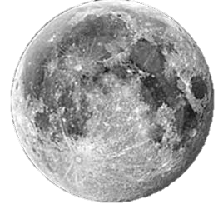

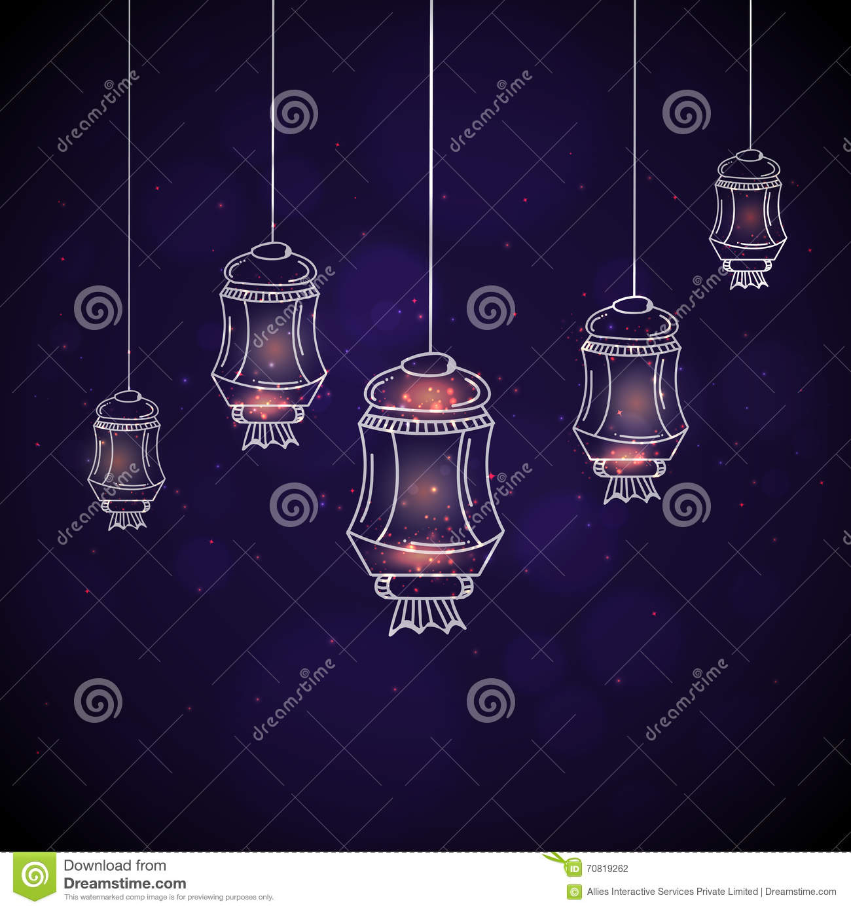

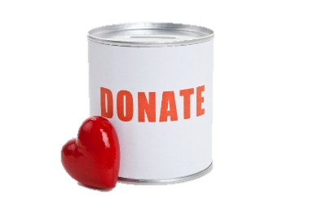

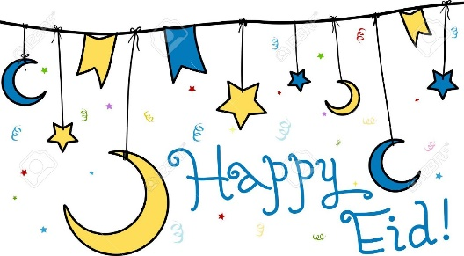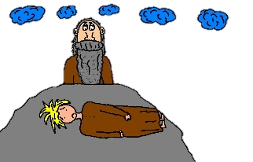





This is a very important occasion for Muslim families and communities,   
so preparations begin in good time. Gifts are bought, clothes are made, food is   
prepared in advance and arrangements are made for the sacrifice

The Qur’an is very clear that it is not the physical act of killing an animal that is pleasing to God.   
What is truly valuable is the personal sacrifice that each individual makes in their heart,   
offernig their life in service to God.

***“****Their meat will not reach God, nor will their blood, but what reaches Him is piety from you****.”***(Qur’an 22:37)

**Sacrificing an animal**It is traditional for each Muslim family or community to buy and sacrifice their own animal,   
 but in Britain it is illegal to kill and animal without a licence and most families do not   
 have the space and skills to keep and kill and sheep or a goat! People may ask a   
 butcher to slaughter a sheep for them; they will then share it amongst family and   
 neighbours as a communal meal. Giving some of this meat   
 to the poor is a sacred duty.

On the day of Id, Muslims will:

* Decorate their houses with colourful lights, banners and flags
* Dress in their finest, newest clothes
* Gather early in mosques or outdoors to perform congregational prayers   
  and listen to a sermon, usually on the subject of sharing and community
* Send ‘Id Mubarak’ greetings cards
* Visit family and friends to share food and festivities
* Visit the cemetary to remember loved ones who have been   
  divided from the family through death
* Give gifts and money to children
* Share a delicious meal, where everyone joins in with   
  food preparation and organisation
* Give generously to the poor

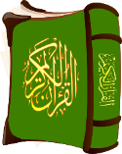

**Breaking the fast**

Id-ul-Fitr is a joyful three-day celebration which takes place at the end of Ramadan, on the start of a new month of Shawwal. It is a well-deserved reward for the completion of a monthof fasting, when Muslims thank God for giving them the strength and self-control needed to give up food and water over so many days. The festival begins with the new moon being observed in the sky, but in Britain, where the weather is often cloudy, Muslims often have to rely on getting the news from other countries.

**A special day**

In Muslim-majority countries, Id-ul-Fitr is a public holiday; in Britain, many Muslim businesses close and Muslim chidlren are often given a day off school, especially in areas where there is a high Muslim population. It is an occasion when people feel a strong sense of generosity and gratitude towards each other and to God.

**Zakat-ul-fitr: festival tax**Islam places a high value on the whole community (ummah) experiencing the blessings and mercy of God, so in addition to the duty to pay the annual 2.5% Zakah tax, Muslims are expected to pay Zakat-ul-Fitr. This donation, given at the end of Ramadan, goes to the   
 poor. It allows everyone, even those in poverty, to eat a generous meal at Id-ul-Fitr.

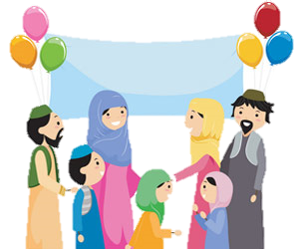

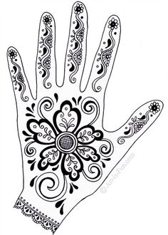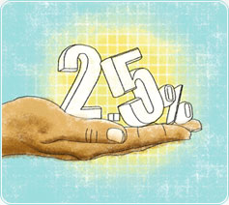

four potatoes farm Regular



Around the world there are many different ways in which Muslims celebrate   
Id-ul-Fitr:

* Egypt: fish recipes form the centrepiece of the feast
* Afghanistan: men gather in parks for egg fights. Armed with hard-boiled eggs, they try to brek each other’s eggs
* Turkey: children are given sweets by neighbours and relatives
* India: women beautify themselves, applying henna to their hands and feet

four potatoes farm Regular