Bungee Shade Regular





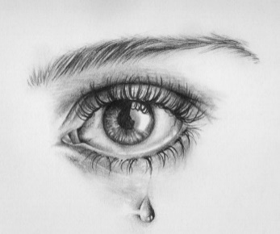

**Shi’a celebration of Ashura today**

For Shi’as, Ashura is an emotionally charged day, remembering the martyrdom of Husayn, the grandsom of Muhammad, and it is celebrated with processions, plays and public displays of grief in the streets. Blood is often spilled and people cry and wail.





Ashura is an important   
festival for all Muslims, but it has enormous   
significance in Shi’a Islam. It is celebrated   
(or commemorated) on the tenth day of Muharram.

Many Muslims today fast on the day of Ashura. The Prophet Muhammad established Ashura as a day of fasting, based on the Jewish day of atonement, when sacrifices are made for the sins of the people. Ashura is an occasion to thank God for saving the Israelites from the Pharaoh. Sunni Muslims remember how much   
Musa (Moses) fasted in gratitude to God for opening up  
 the Red Sea to allow his people to escape from   
the Egyptian chariots.



**Shi’a Islam: The Martyrdom of Husayn**Ashura is of particular importance to the Shi’a Muslim community because it remembers the death of Husayn in battle at Karbala in 680CE. This event triggered a split between Sunni and Shi’a Muslims that continues to divide Islam today. Shi’as believe that Husayn was the rightful successor to the Prophet Muhammad, so the massacre of Husayn and his followers carries great significance. They refer to Husayn as the third Imam, following his father Ali and his older brother Hasan. Still today they remember his betrayal and death with a deep sense of injustice.





**How is Ashura celebrated around the world?**

The death of Husayn gave rise to Shi’a cult of martyrdom and to a sense of   
betrayal and struggle against injustice and oppression. Ashura is a day of great sorrow, mourning and self-mutilation, where much public grief is expressed.   
Central to the events is the need to share in the sufferings of Husayn. Ashura is celebrated in communities across the Shi’a world (for example, in Iran and   
Iraq), but many Shi’a Muslims feel the need to make the pilgrimage to Karbala   
every year to take part:

* Men and women dress in black and march through the streets,   
  slapping their chests and chanting
* There are processions and religious gatherings
* Plays re-enact the martyrdom
* Fervent men beat themselves with chains and cut their   
  heads with swords

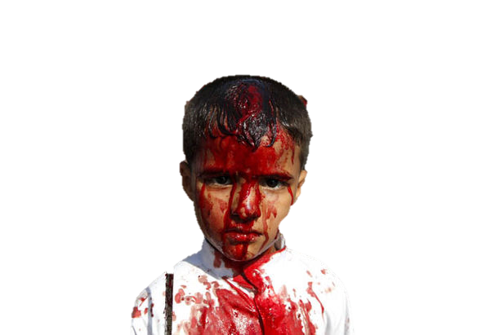





**Ashura in Britain today**

Ashura is not a public holiday in Britain, but Shi’a Muslim children can be given permission to have the day off school. Many people will fast and pray on this day. In cities such as Manchester and London, Shi’as gather together in large crowds and take part in public marches. The men often slap their chests violently, in time to their chanting, but it is uncommon to see them drawing blood through whipping and beating themselves, as happens in many countries in the Middle East. Those who feel that they should lose blood may be encouraged, by Shi’a leaders, to donate blood to the blood transfusion service.

Bungee Shade Regular

Ashura is an Islamic holiday observed on the 10th of Muharram, the first month of the Islamic year. The word Ashura means "10," denoting the date of the holiday.

Ashura has been a day of fasting for [**Sunni**](http://www.bbc.co.uk/religion/religions/islam/subdivisions/sunnishia_1.shtml) Muslims since the days of the early Muslim community. It marks   
two historical events: the day Nuh (Noah) left the Ark, and the day that [**Musa**](http://www.bbc.co.uk/religion/religions/islam/history/musa.shtml)(Moses) was saved from the   
Egyptians by Allah. [**Shi'a**](http://www.bbc.co.uk/religion/religions/islam/subdivisions/sunnishia_1.shtml) Muslims in particular use the day to commemorate the martyrdom of Hussein,   
a grandson of the Prophet, in 680 CE.

For Shi'a Muslims, rituals and observances on Ashura consist primarily of public expressions of mourning   
and grief. Some Shi'as express mourning by flagellating themselves on the back with chains, beating their head or ritually cutting themselves. This is intended to connect them with Husayn's suffering and death as an aid to   
salvation on the Day of Judgment.

Passion plays commemorating the death of Husayn are also presented on Ashura. In London, around 3,000 Shi'a Muslims gather at the Marble Arch on Ashura for a mourning procession and speeches.

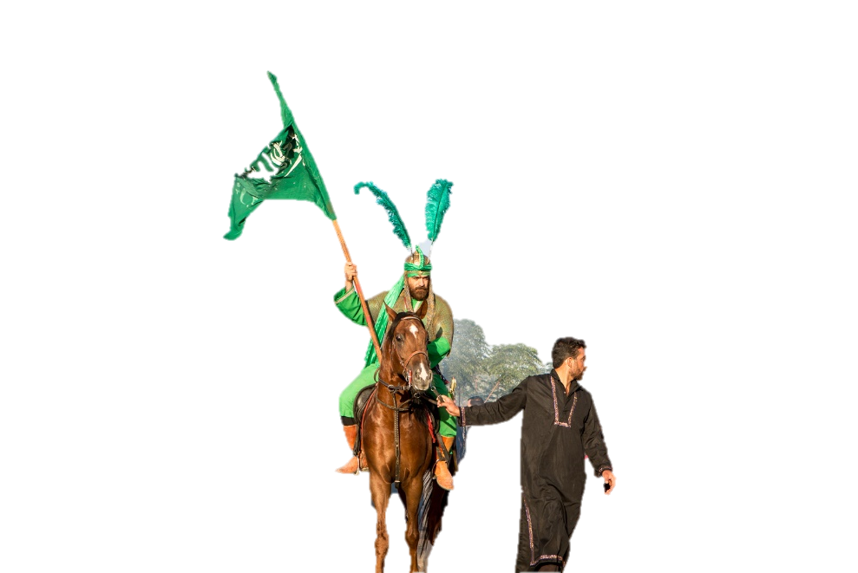

Bungee Shade Regular

Bungee Shade Regular

