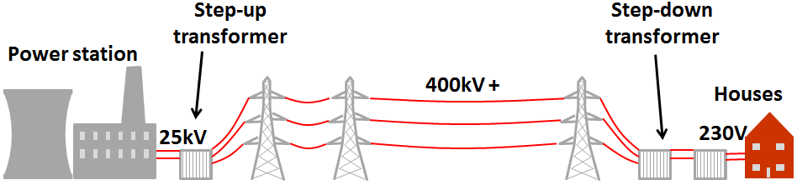

**Power**Energy in an electrical circuit is transferred by a moving charge. The charge has to work against resistance, so work is done. Work done is the same as energy transferred and depends upon power.

Appliances have a power rating, the maximum operating power.

An appliance with a lower power rating will be cheaper to run (less energy transferred per second).

A higher power rating might not mean more energy is transferred usefully. It could be less efficient than another appliance so only transfer the same amount, or less, energy to useful stores.

**AC and DC**  
With **alternating current** (AC) the current constantly changes direction. It is produced by an alternating voltage where the positive and negative ends keep alternating.  
The UK **mains** supply is **AC** at **230V**. It has a frequency of **50Hz**.

With **direct current** (DC) the current always flows in the **same direction**. **Batteries** produce a DC voltage.

All of the AQA science revision sheets at www.tes.com/teaching-resources/shop/teachsci1

**Meeting Demand**Power stations have to meet the **demand** for electricity, which **varies** during the day. They usually run **below maximum capacity** so more electricity can be generated to meet demand, such as during big sporting events.

**Electrical Wiring**Most electrical appliances are connected to the mains with a three core cable (3 copper wires coated in insulating plastic):

**Charge**  
Energy is **supplied** to the charge at a **power source**, ‘raising’ through a potential.  
Energy is **given up** by the charge at **components** as it falls through a **potential drop**.

Charge flow (Coulombs, C)

$$E=QV$$

Potential difference (V)

**Power Calculations**  
Power (W) depends upon the potential difference (V) and current (A):

**National Grid**A network of cables that connects power stations to consumers.  
A huge amount of power is needed. This is achieved with a **high pd** but a **low current**. A high current would cause the wires to heat up, wasting a lot of energy. It is **cheaper** to increase the pd and keep the current low for a given power output.

Or, if the potential difference is not known:

$$P=I^{2}R$$

$$P=VI$$

Time (s)

Power (W)

Energy  
transferred (J)

$$E=Pt$$

**Live Wire**  
If you touch the live a large pd is produced across your body and the current flows through you. This **electric shock** can injure or kill you.

A connection between the live and earth creates a **low resistance** path to earth so a **large current** will flow. This could cause a **fire**.

* **Live** (brown) – Provides the alternating pd at **230V.**
* **Neutral** (blue) – Completes the circuit carrying the current out of the appliance at **0V**.
* **Earth** (green and yellow) – A safety feature. Prevents the appliance becoming live if there is a fault so does not normally carry a current. It is at **0V**.

**Electricity In The Home**