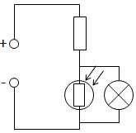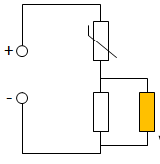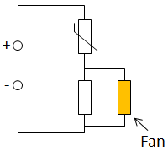a rectangle lying flat with two horizontal lines coming out of its sidesCircuit symbol for LEDa rectangle lying flat with two horizontal lines running out of either side. a circle runs around the rectangle, and two arrows point downwards at the rectangle, from the top left.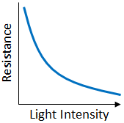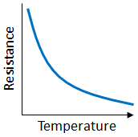a rectangle lying flat with two horizontal lines running out either side of it. A 45 degree line runs through the rectangle which bends at the bottom to run parallel with the base of the rectangle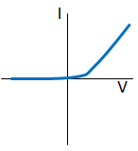Circuit symbol for diode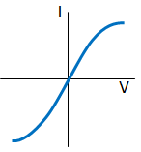a circle with an 'x' inside, attached to a horizontal line either side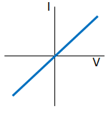a rectangle lying flat with two horizontal lines coming out of its sides

All of the AQA science revision sheets at www.tes.com/teaching-resources/shop/teachsci1

An example with numbers:

High temperature = low resistance of thermistor, so high pd across resistor. Also 7V across fan so it turns.

7V

2V

9V

Low temperature = high resistance of thermistor, so very low pd across resistor. Only 1V also across fan so it does not turn

1V

8V

9V

Connecting the component across the variable resistor (LDR or thermistor) will have the opposite effect.  
When it is dark the resistance of the LDR will be low, meaning the pd across both the resistor and bulb will be high. Therefore the bulb gets brighter as it gets darker.

The pd of the power supply is **shared** between the fixed resistor and the thermistor.  
If the **temperature increases** then the **resistance** of the thermistor will **decrease**.  
This means there will be a **larger pd** across the **resistor** and therefore the fan, which will go faster (fan and resistor will always have the same pd as they are connected in parallel).

**Sensing Circuits**

Variable Resistor

Closed switch

Open switch

+

**Other Components**

+

Battery

Cell

Voltmeter

A

A

Ammeter

Light Emitting Diode (LED)

**Light Dependent Resistor (LDR)**

As the light intensity increases the resistance drops. This means more current can flow.

Can be used in automatic night lighting and outdoor security lights.

As the temperature increases the resistance drops. This means more current can flow.

Can be used as temperature detectors, such as in car engines and thermostats.

**Thermistor**

At a constant temperature the current is directly proportion to the voltage.

This means it obeys Ohm’s Law.

The current can only flow in one direction because a diode has a very high resistance in the opposite direction.

**Diode**

As the voltage increases the current increases. This causes the filament to get hotter, meaning the resistance increases. Therefore as the voltage continues to increase the current levels off.

**Filament Bulb**

**Resistor**

**Electrical Components**