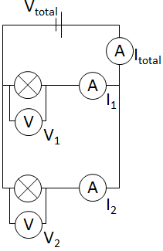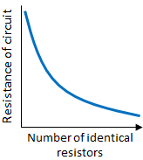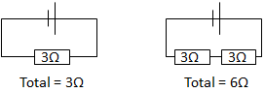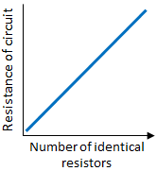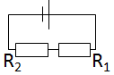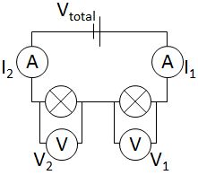

All of the AQA science revision sheets at www.tes.com/teaching-resources/shop/teachsci1

Required Practical

see practical sheet for detail

**Factors Affecting  
Resistance**Length or diameter of wire, temperature and the types of components affect resistance. These can be investigated.

Required Practical

see practical sheet for detail

V stays the same.  
If I goes up then R must go down.

As more resistors are added in **parallel** the total resistance will **decrease**.

This is because resistors in parallel have the **same pd** across them as the power supply. Adding another loop to the circuit means the current has more than one way it has to go. Therefore the **total current** around the circuit **increases**. An increase in current means a **decrease** in **resistance** (V = IR)

As more resistors are added in **series** the total resistance will **increase**.

**Investigating Resistance**

**Parallel Circuits**

**Current** is shared across the components: Itotal = I1 + I2 +…

**Potential difference** is the same across all components: V1 = V2 =…

Total **resistance** will fall if two or more resistors are added in parallel.

**Series Circuits**

**Current** is the same throughout the circuit: I1 = I2 = …

**Potential difference** is shared across the components: Vtotal = V1 + V2 +…

**Resistance** adds up: Rtotal = R1 + R2 + …

Re-arranged to:

$$R=\frac{V}{I}$$

V

I x R

Resistance (Ω)

Potential difference (V)

$$V=IR$$

**Resistance**Resistance of a component can be calculated if you know the potential difference and the current.

**Charge**Current depends on the rate of flow of charge.

Current (A)

Time (s)

Charge (coulombs, C)

$$Q=It$$

**Key terms  
Current** is the flow of electrical charge. Measured in amps (A)

**Potential difference** is the force that pushes the charge around. Measured in volts (V).

**Resistance** is something that flows down the flow of current. Measured in ohms (Ω).

**Electrical Circuits**