Color Time!

On the Day of Judgement, the dead will be raised from their graves and all people will stand before God to be sentences according to the way they have lived their lives. A book which represents everything an individual has done, is presented to each of them. If the person’s good deeds outweigh the bad, then they will receive the book in their right hand and pass into heaven. If it is placed into their left hand, they will be among the damned.

On the Day of Judgement, the Book of Deeds will be read, in which ‘***every small and great thing is recorded***.’ (Qur’an 54:52)

The Qur’an gives many warnings about the Day of Judgement and Muslims are encouraged to question themselves: Am I ready to face death? What have I done to prepare for that day?



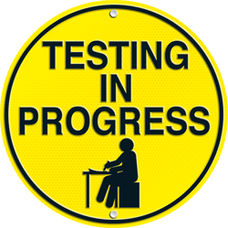



Many signs will mark the end of the world, but the most importance will be the appearance of the Mahdi. His return will coincide with the second coming of Isa (Jesus).   
  
A false messiah will also attempt to deceive the people. Other signs include: abundance of earthquakes, the spreading of killing, rejection of Islam, increase in dishonesty, drunkenness, obscenity, nakedness and fornication.   
  
Society will be full of terrible corruption and chaos.

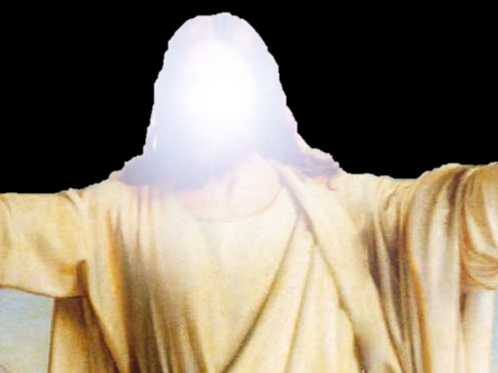

For Muslims, this world is not all   
there is. Our human existence will continue   
after death; our earthy life is just a preparation   
for the eternal life to come (Akhirah). Our mortal lives are a test and we will be judged according to how we have lived. As humans, we have been given free will, so we are able to make choices about what to believe and how to treat others.   
  
We will be held responsible for these thoughts and actions when God comes to judge us on the last day.

**The Angel Israfil** will blow a trumpet to announce   
the Day of Judgement. The trumpet is constantly   
on his lips, awaiting the command   
from God

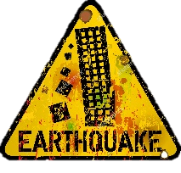







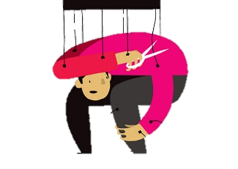

Color Time!

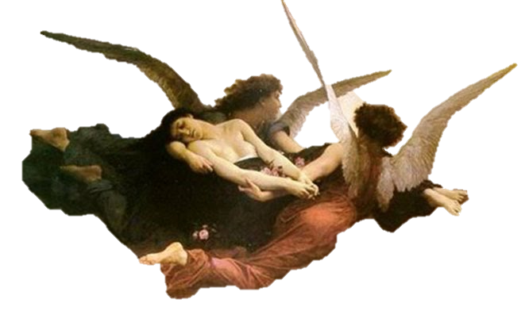

Color Time!

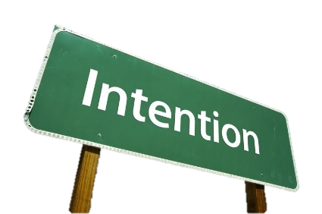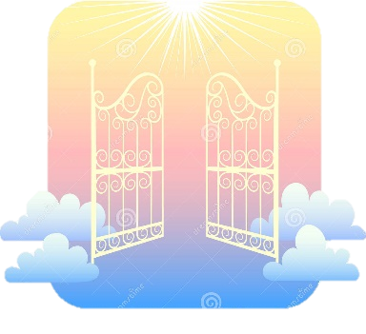

The two terrifying judging angels, Munkar   
and Nakir, will question each person, testing their faith. In order to give the correct answer to their questions, it is not enough to just learn to recite the Shahadah. If the person has not truly lived a life of submission to God, following the Five Pillars, they will be incapable of giving the right response   
on the day.

**Barzakh**Only God knows when the Day of Judgement will come. Muslims believe that, for those who die before that day, the angel of death, Azrail, will come to take their souls to await the day. They will be kept in a state of barzakh (waiting) until the sound of the final trumpet is heard.

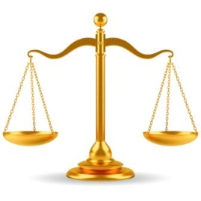

Islam provides the most graphic descriptions of what awaits after   
death. Heaven and hell are described as very real places, but some Muslims   
interpret these descriptions symbolically, since what exists beyond death must exist in   
a different dimension from our own world.

Heaven (**Janna**) is a state of joy, happiness and peace. After judgement, people will   
pass over the very narrow bridge of **As-Sirat**. Those who have been blessed by   
God will successfully cross to heaven (Janna) on the other side. This will include those   
who have lived faithful and moral lives, those who have been persecuted for their faith in   
God and those who have fought for God. Muslims believe that heaven is a reward for living   
a good life, so everything that one longs for on earth will be found in paradise:  
 beautiful gardens, delicious food, gently flowing rivers, lovely serving   
maidens and reclining couches.

Hell (**Jahannam**) is a state of torment and suffering. The wicked, those whom God   
has damned, will fail to pass over the As-Sirat Bridge. In trying to cross they will fall  
 into hell, which is a place of terror, where the damned will face boiling water,   
scorching fire and black smoke. As well as experiencing the physical   
torment, those condemned to hell will suffer because they are   
separated from God, without   
hope of return.

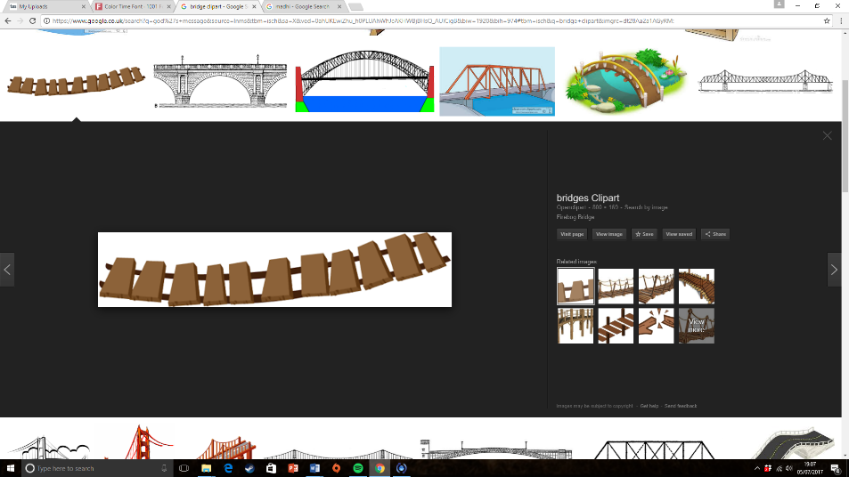

God judges each person’s actions, but intentions (niyyah) are also taken into consideration.

If the person has the intention to do a good deed,   
but was unable to carry it out, this is counted as a   
good deed

* If they intended and carried out a good deed, this is counted as ten good deeds
* If the person intended a bad deed, but did not do it, that is counted as a good deed
* If they intended and carried out a bad deed, God records that as one bad deed



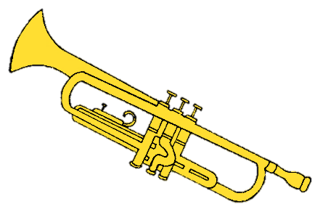

Image result for heart clipart

Color Time!