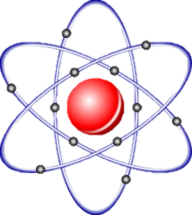

In Genesis 2, Adam lives in the Garden of   
Eden – a paradise. God creates a ‘companion’ for Adam   
from his rib. Adam names her ‘Eve’.

“Then the Lord God made a woman from the rib he had taken   
out of the man, and he brought her to the man.

The man said, “This is now bone of my bones, flesh of my flesh;   
she shall be called woman, for she was taken out of man.”

(Genesis 2:22-23)

God gives Adam and Eve one command, which is to not eat from   
the Tree of Knowledge of Good and Evil that grows in the garden.

God says, “You must not touch it, or you will die.” (Genesis 2: 3)

The Genesis creation story makes it clear that humankind is unique   
among God’s creation, as we are:  
 ‘created in God’s image’.

Humans are made in the image of God, but are sinful and in need of   
God’s forgiveness. In Genesis, people have a clear purpose – to have   
‘dominion’ or powers over the earth, but this must be exercised   
through Stewardship on God’s behalf.

For Christians, God is the creator of the   
universe. They believe that whatever the exact   
process was that created the universe, God is the   
overall architect of that creation.

The main events in creation are:

1. Creation of the universe
2. Creation of the earth
3. Creation of Adam and Eve (humankind)
4. Temptation of Adam and Eve
5. The fall of humankind from grace

**Genesis 1 tells us:**  
“*In the beginning God created the heavens and the earth. Now the   
earth was formless and empty, darkness was over the surface of   
the deep, and the Spirit of God was hovering over the waters.   
And God said, ‘Let there be light,’ and there was light*.”   
(Genesis 1: 1-3)

The Big Bang is the idea that about 13,700 million   
years ago all the matter in the universe was concentrates   
at a single point. A huge explosion – A Big Bang – sent it all   
spiraling outwards, eventually creating the universe as we know it today.

Scientists believe that they have found evidence for the Big Bang,   
including that the universe is still expanding.

The Big Bang is compatible with Christianity because some Christians   
believe that it is impossible for the universe to have come from ‘nothing’.   
Therefore, God must have started the Big Bang.

The theory of Evolution states that life has evolved from less complex   
forms of life. This, too, is compatible with Christianity because some   
Christians believe that evolution could have been part of God’s plan   
and that he intended for less complex organisms to develop into humans.   
Here, a ‘day’ in the story of Creation simply means a ‘period of time’.   
Not all Christians believe that the Bible should be taken literally,   
word-for-word. Rather, it can be understood liberally or with  
 appreciation that the stories in the Bible, although   
true, might be myths.

Genesis 3 describes ‘The Fall’ – when Adam and   
Eve are tempted by a serpent (the devil) to eat from   
the Tree of Knowledge of Good and Evil against God’s will.

The serpent tricks Adam and Eve into thinking that if they eat from   
the tree, they will become ‘like God’ and be as knowledgeable as God.   
Eve gives in to the temptation and then gives some of the fruit to Adam.

They confess to God but, as a punishment, God sends them from the   
Garden of Eden. They are no longer able to eat from the Tree of Life and   
therefore they are no longer immortal and death enters the world.

For Christians, this represents the point where God’s perfect   
relationship with humans breaks. For some Christians, this is why   
humans are born with ‘original sin’.

This broken relationship is the reason why it was necessary for Jesus   
to die on the cross, as his death paid for human sin and restored  
 the broken relationship with God.



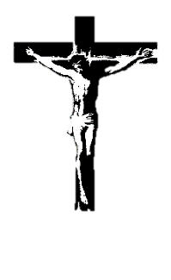

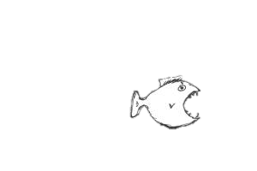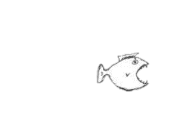

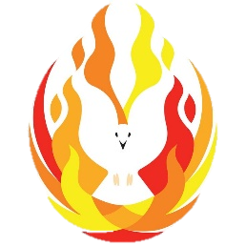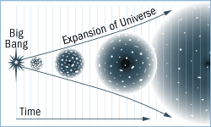





Stewardship

The idea that people have a God-given duty to take care of the earth in a responsible way, looking after both the environment and animals.

Humans act as caretakers of God’s world, preserving and conserving the environment.

Dominion

Having control over the earth and managing God’s creation.   
This is a more active role and gives mankind more power and autonomy over their choices regarding the earth and the environment.

Original Sin

The ‘evil’ or ‘sin’ that is innate in all human beings, as a consequence of The Fall.

**John 1:1-5**

“*In the beginning was the Word and the Word   
was with God, and the Word was God. He was with   
God in the beginning. Through him all things were made.   
In him was life, and that life was the light of all mankind.   
The light shines in the darkness, and the darkness has not   
overcome it*.”

Some people believe that ‘Word’ refers to God’s creative self-expression, and the purpose and plans that he put in place as he created the universe.

Most Christians however, understand the ‘Word’ to be a reference to Jesus, the second part of the Trinity. Jesus as the ‘Word’ is central to the belief that Jesus is God as a part of the Holy Trinity.

Therefore, in this quote, “*In the beginning was the Word and   
the Word was with God, and the Word was God”* Jesus,   
or ‘the Word’ was present at the beginning of creation   
and that he is God.

Christians believe different things when it comes to  
interpreting and understanding scripture (the Bible):

**Fundamentalism**: Fundamentalist Christians believe the store to   
be absolutely true in every detail – it is word-for-word true. They   
have a literal interpretation of the creation story.

**Liberalism**: Liberalist Christians believe that the story is more   
symbolic – it is metaphorical and myth-like in nature, so the account   
needs to be interpreted. They do not believe every details of the story   
to be literally accurate or true.

**‘Day’**: There are diverse views on how the word ‘day’ should be  
 interpreted. A literal Christian (a fundamentalist) would mean   
that a day is 24 hours exactly. A liberal Christian may read ‘day’ as   
a period of time and may actually represent millions of years.

Differences in view are due to how different Christians believe  
 the Bible should be interpreted. Regardless of whether   
Christians believe in the Big Bang theory, ***all*** Christians   
believe that God is the ultimate creator of   
the universe.

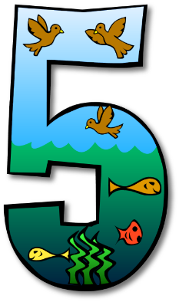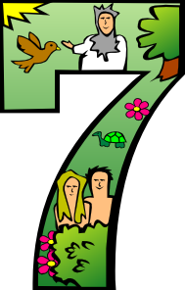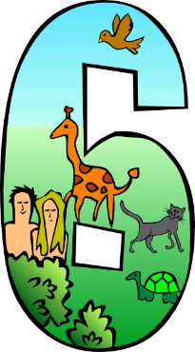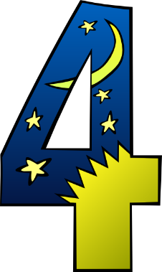

Day 1

Night and Day

God called the light ‘day’ and the darkness he called ‘night’

Day 2

Heavens and Waters

God made the firmament and separated the waters which were underneath

Day 3

Land and Plants

God said, ‘let the dry land appear. Let the earth put forth vegetation.’

Day 4

Sun, Moon and Stars

God made two great lights; he made the stars also

Day 5

Birds and Fish

‘Let the waters bring forth swarms of life and let birds fly above the earth’

Day 6

Living Creatures and Humans

‘Let us make man in our image, after our likeness’

Day 7

God rested

On the   
seventh day God finished   
his work and   
he rested.







