Moaren RegularMoaren Regular

**Akhirah (the afterlife)**:   
Belief in the final judgement and life after death. This life is a preparation for the eternal life that follows. On the last day there will be a time of judgement, when Muslims will have to account for their lives

There is no official **creed** in Islam. (A creed is a set statement of faith that all religious believers follow.) However, for Sunni Muslims, there are **six central beliefs**, or articles of faith, which define their understanding of God. This teaching can be found in the **Hadith**, where Muhammad is recorded as saying, ***“You must believe in Allah, his angels, his holy books, his messengers, in the Last Day and in fate (both in its good and in its evil aspects).”***

Although these six beliefs are central to the Islamic faith, they are not the only important beliefs. Others include: the **jihad** (striving to do what is right, for God. The **greater jihad** is the struggle that each person has, as an individual, to follow God’s will in their life. The **lesser jihad** is the fight to defend Islam) and the submission to the will of God.

* **Risalah (prophethood)**
* **Malaikah** (angels)
* **Holy books**
* **Allah** (God)
* **Akhirah (the afterlife)**
* **Al**-Qadr (God’s predestination)





All Muslims share the central beliefs of the   
Islamic faith: the understanding that there is **one God** (Allah)  
who is **creator**, **protector** and **judge**; the belief that Muhammad is the Seal of the Prophets, to whom God revealed the Qur’an. However, over the centuries, as Islam developed in different cultures and societies, Muslim scholars developed different ways of understanding the faith.   
  
Today there are some significant differences in the way different Muslim groups interpret these truths.

Moaren Regular

**Holy books**: God has revealed his word to humans in the Qur’an. This tells Muslims all they need to know about how to live their lived. Other inspired scriptures include the **Tawrat of Musa** (Torah), the **Zabur or Dawud** (Psalms) and the **Injil of Isa** (Gospels).



**Risalah (prophethood)**:   
God has spoken through numerous prophets throughout time, including Adam, Nuh (Noah), Ibrahim (Abraham), Musa (Moses), Isa (Jesus). However, Muhammad  
 is the greatest   
prophet.

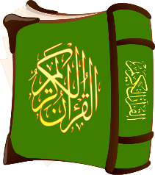

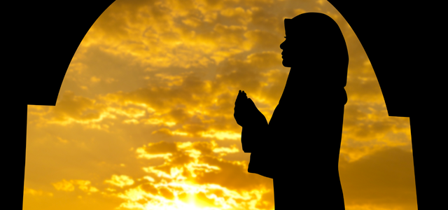



**Allah** (God): the unity and oneness of God is called Tawhid. Like Jews and Christians, Muslims believe in one God. The Arabic word for God is Allah, which simply means ‘the (al) God (ilah)’.

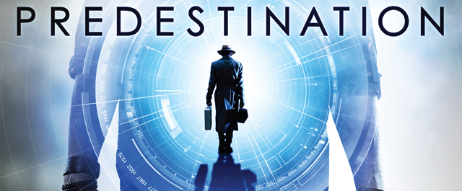

**Malaikah** (angels): God created angels to interact with human lives, bringing his divine message. Each Muslim has two guardian angels who record that person’s good   
and bad actions.

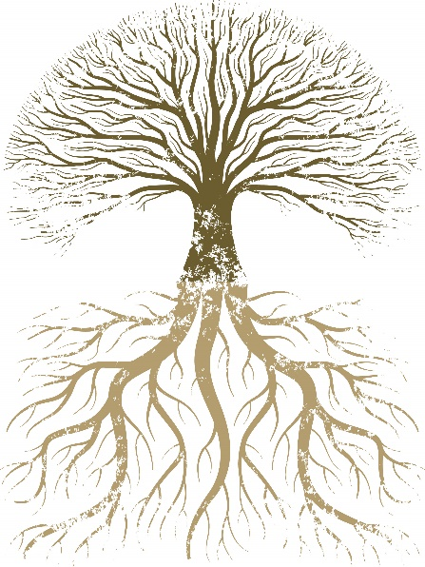

Moaren Regular

**Al**-Qadr (God’s predestination):   
God is responsible for everything and has set out a divine destiny for all things. God has written down all that has happened and all that will happen in the universe. However, this does not take away   
human free will.









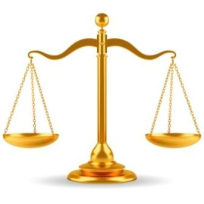

Moaren RegularMoaren Regular

Shi’a Islam emphasises the   
importance of five fundamental principles   
which are sometimes called the ‘**roots of   
religion**’. Every individual must make themselves aware   
of these truths as the foundation of their faith.

Usul ad-Din, the five roots of religion, can also be referred to as the ‘**foundation of faith**’.

* **There is one God who has no equals; he is a divine unity**
* **He cannot be compared to anyone or anything**
* **He is perfect and unique and possesses infinite power and knowledge**
* **He is immortal (he was never born) and has no partner or children**
  + **He alone should be worshipped**
  + **“He is God [who is] One, God, the   
    Eternal Refuge.”   
    (Qur’an 112:1-2)**

Moaren Regular

Muhammad was the last prophet   
(most Muslims believe). Shi’as believe that  
 after his death, God appointed 12 infallible   
Imams to guide the Muslim community, leading  
 them on the path set by Prophet Muhammad. These  
 Imams are part of what Shi’as call Ahl al-Bayt (the   
Family of the House)

The Imams are part of Prophet Muhammad’s extended household. Of the 12 Imams, 11 have been killed. They believe that the 12th (or hidden) Imam is still alive, but is   
in hiding (occulation), waiting to reappear and rule on   
earth with justice. This 12th Imam is sometimes  
 referred to as ‘Mahdi’

The Day of Judgement will bring  
 the resurrection, when all humans will   
be physically raised to life to be judged by God

God will reward the good and punish the evil

“***So whoever does an atom’s weight of good   
will see it, and whoever does an atom’s weight   
of evil will see it***.”   
(Qur’an 99:7-8)

* God is perfect justice, fairness and wisdom.   
  He does not wrong anyone and will not tolerate wrongdoing
* God cannot abuse his power by performing acts   
  that go against his own nature to be just and fair
* Humans must be responsible for their own actions,  
   good and bad
* God has appointed prophets and messengers to   
  guide humans, showing them how to live in peace   
  and submission to God
* God sent 124000 prophets; some of these brought   
  God’s divine scriptures with them
* Muhammad was the Seal of the Prophets,   
  meaning that he brought the final, perfect and   
   unchanging message of God

Moaren Regular



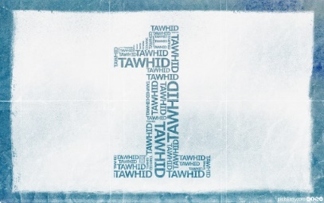

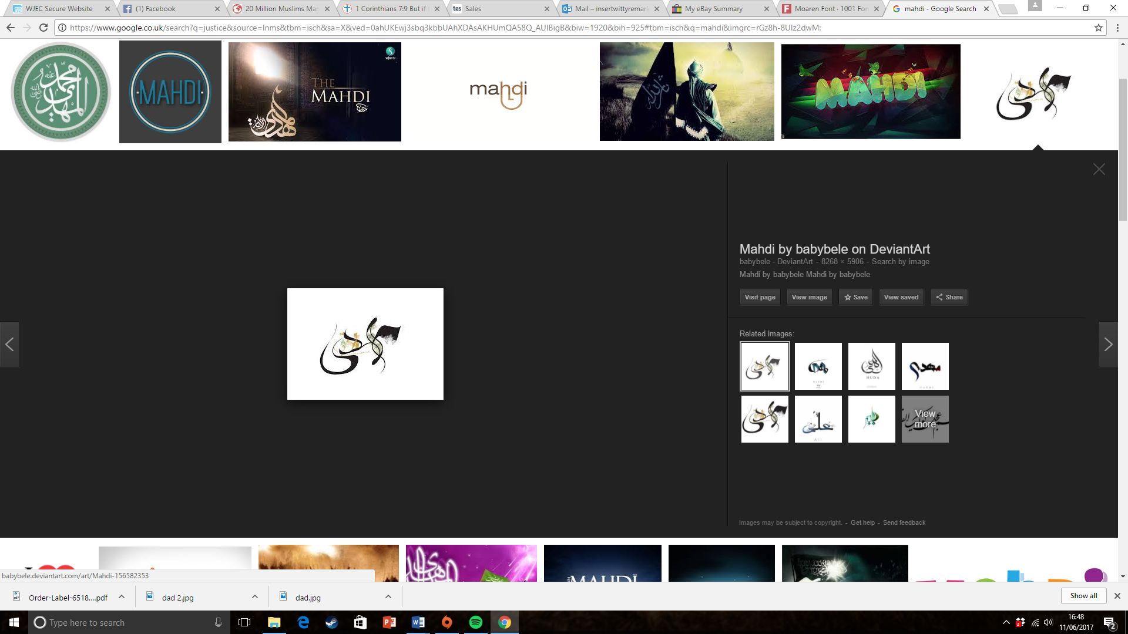Moaren Regular

