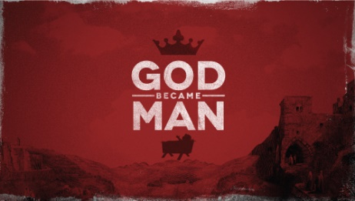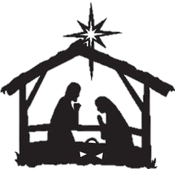Gurindam RegularGurindam Regular

The run up to Christmas may include any of the following methods of celebration:

1. **Nativity** or crib scenes in homes and churches
2. Nativity **plays** are acted out in schools and churches
3. **Christingle** services are held where children make a Christingle (orange with a candle) to show that Jesus was the light of the world
4. Carol concerts are held where people sing **Christmas carols**
5. People exchange **Christmas cards** with a religious image and greeting
6. Decoration of houses, inside and out
7. Advent **wreath** decorations
8. **Midnight Mass** communion (Eucharist) service takes place on   
   Christmas Eve
9. Some Christians may fast during Advent, particularly in the Roman   
   Catholic Church. This is so that Christians can spend the time focusing   
   on the true meaning of Christmas and can prepare for   
   commemorating the incarnation (birth of Jesus – God made flesh)



Christian churches divide their year into different seasons.   
These seasons are called Advent, Christmas, Epiphany, Lent and   
Easter. The times in between these seasons are known as ‘Ordinary time’.

Each of these seasons helps Christians focus on particular aspects of God and the plans that He has for his people. There are different characteristics, colours and festivals associated with each of the Church seasons too.

Christian celebrations mark important events in the life of Jesus or mark important events in the history of the Christian Church. Because Britain is traditionally a Christian country, the major celebrations of festivals became the basis of public holidays in Britain. The two most important Christian celebrations are Christmas and Easter.

1. Celebrates the birth of Jesus. This is known as the **incarnation**   
   (when God became human flesh)
2. Christians do not think that Jesus was actually born on Christmas day,   
   but they mark this day in the Christian calendar to focus on the   
   **miracle** of the incarnation
3. **Advent** is a time of preparation, where Christian prepare for Christmas.   
   Advent begins four Sundays before Christmas.
4. Traditionally, Christians **fast** during advent, although Western Churches   
   no longer fast
5. Many people have advent calendars or advent candles to count down the   
   days until Christmas
6. On Christmas day itself, Christians may: attend church services; celebrate   
   a feast with their families; exchange gifts
7. Christmas is also celebrated by non-Christians, where Christmas has no   
   particular religious significance. Many people regard Christmas as a   
   **‘wintertime’ festival** rather than a religious one





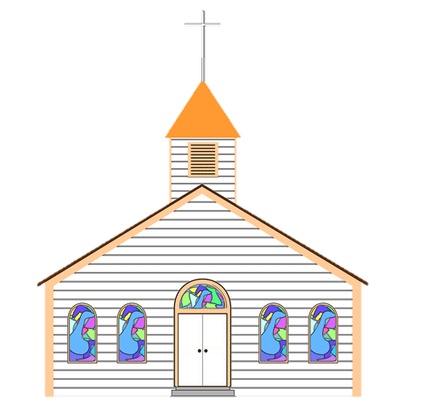

Gurindam Regular

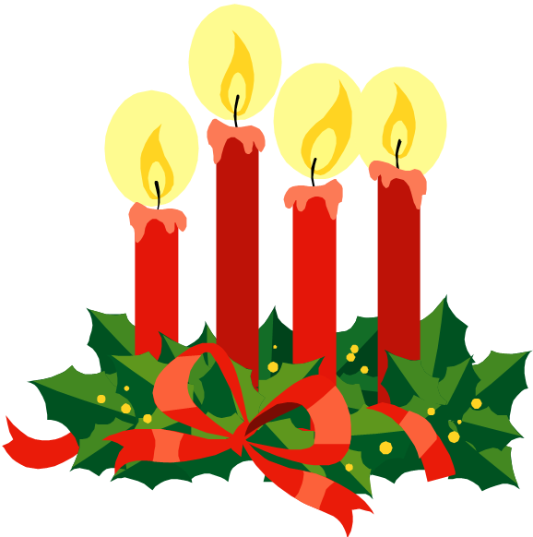

Gurindam Regular

Gurindam Regular

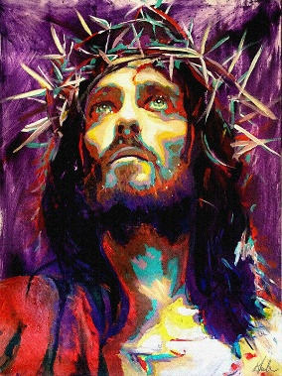

Christian celebrations mark important events in the life of Jesus or mark important events in the history of the Christian Church. Because Britain is traditionally a Christian country, the major celebrations of festivals became the basis of public holidays in Britain.

The two most important Christian celebrations are Christmas and Easter.

Gurindam Regular

**Maundy Thursday**: Remembers Jesus’ last meal   
with his disciples. During this meal Jesus shared bread and wine and   
told the disciples that they represented his body and blood. To remember this,   
church services (Eucharist/Communion) will be held. Jesus also washed his   
disciples’ feet during this meal, so in some RC churches the priest will also wash  
 the feet of some members of the congregation

**Good Friday**: Remembers Jesus’ death on the cross. Christians believe this sacrifice to be an act of Salvation, enabling humans to atone for their sins and be with God.  
**Easter Sunday**

* Marks Jesus’ resurrection – when those coming to his tomb found it empty
* It is the most important day in the Christian calendar and is a day of celebration
* Christians attend special services and churches are filled with flowers
* Christians also celebrate in the following ways:
  + Exchanging cards with family and friends
  + Exchanging Easter eggs
  + Attending church services in Lent
  + Visiting cemeteries to leave flowers for deceased loved ones
    - Personal reading of the Bible
    - Evening vigil on the Saturday of Holy Week

Easter is the most important festival in the Christian calendar – it   
remembers the death and resurrection of Jesus

Lent is a period of 40 days leading up to Easter. It remembers the time Jesus spent in the   
desert fasting and praying. The devil tried to tempt Jesus during this time but he resisted  
 the temptations.

Lent begins with Ash Wednesday. Roman Catholics attend special church service where   
their heads are marked with the shape of the cross. Ash Wednesday is traditionally a day   
of fasting. To remember how Jesus fasted in the desert, Christians often give up something   
for Lent. The day before Lent starts is known as Shrove Tuesday, or Pancake Day, and   
was an opportunity to use up the foods that Christians would be giving up during Lent

**Holy Week**

* This is the week when Christians remember the events in Jesus’ life that   
  led up to his life:
* **Palm Sunday:** Remembers the arrival of Jesus in Jerusalem. In some   
  denominations, e.g. RC, Christians receive crosses made of palm   
  leaves to remind them of this event

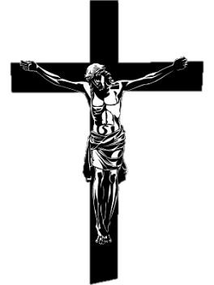

Gurindam Regular

