Beffle Medium

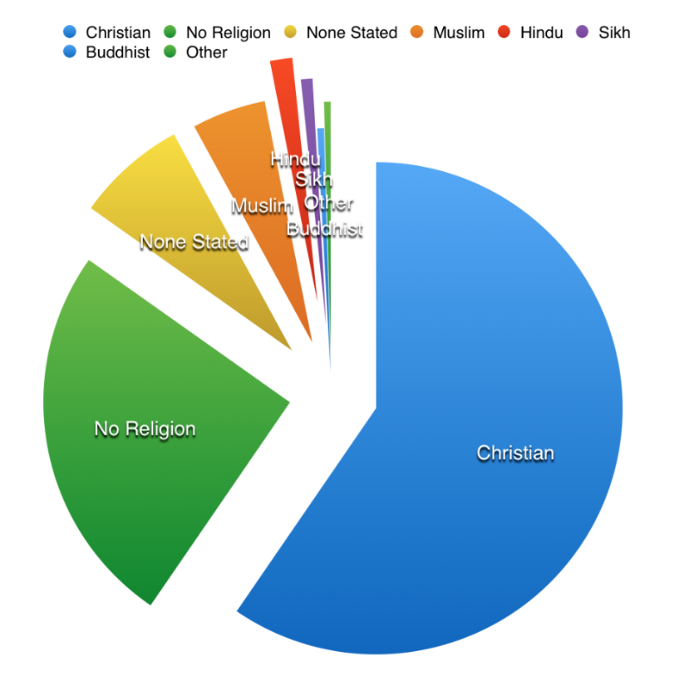

Beffle Medium

Beffle MediumBeffle Medium

Local Baptist church is opening a food bank every Friday

Pensioners’ Christmas Dinner this Saturday!

Local church feeds the town’s homeless!

Catholic Church opens shop to raise money for those living in poverty

Christian businessman funds bottled water and flip flops for distribution by the pastors in city centre!

Volunteers needed to distribute Christian Aid collection envelopes!

Beffle Medium

* The Christian Church faces many challenges in 21st Century Britain
* Religious beliefs are regarded as out of date or irrelevant
* Many people claim to be agnostic (unsure whether God exists) or atheist (believe that there is no God)
* Christianity is one of many religions followed by people in Britain. This means that the religious landscape is pluralist, with people following a number of religions
* Attendance at churches has declined
* The celebration of religious festivals for many have lost their religious significance, e.g. Christmas. Many people see this as an opportunity to spend time with family and friends, sharing good will with others.   
  Cards and presents are exchanges without any religious  
   connection. It is celebrated without a Christian reference and   
  much more as a secular (non-religious) celebration.



**Activities:**

1. Refreshments after Sunday service
2. Meals for the homeless
3. Food banks
4. Coffee mornings for the elderly
5. Youth clubs
6. Crèche facilities for young mothers
7. Summer fairs
8. Organisations like cubs and brownies
9. Fitness classes or slimming groups
10. Family and community centres
11. Emergency shelters
12. Blood drives

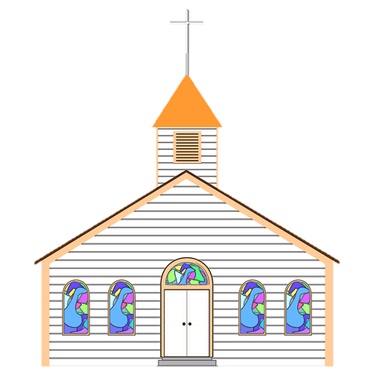



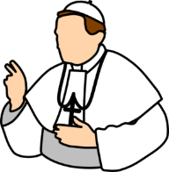

Christianity was introduced to Britain by the Romans almost 2000 years ago. This long history means it is deeply embedded in the laws, festivals and traditions of the UK. The Church of England is the ‘established’ religion of England. This means that it has links to   
the government and other official bodies such as the court system (people swear an oath on the Bible when testifying in court).

In 16th Century, King Henry VIII broke away from the Catholic Church and the authority of the Pope and made himself the head of the Church of England. Today, as well as being Head of State, the monarch is the Supreme Governor of the Church of England. All monarchs are crowned by the Archbishop of Canterbury (a Christian authority).

Primarily a church is a place of worship, but as part of living out the values Jesus demonstrated in the Gospels, churches reach out into communities in a variety of ways.  
Some of the church services might be religious in nature, e.g. marking important rites of passage for individuals and families. Services such as baptisms, confirmations, marriages and funerals will be held in the church.  
Lots of churches have an attached ‘church hall’ and this may be used for a variety of activities.

The UK parliament makes all UK laws by   
passing Acts of Parliament. It is made up of two ‘houses’,   
one of which includes 26 of the most senior Church of   
England bishops.   
For laws to be passed they must be approved by both   
houses of parliament. So the Church of England has a direct   
role in shaping UK law.   
Meetings of both houses of parliament open with Christian prayers and many of the laws of the UK reflect the  
 teaching of some of the Ten Commandments,   
e.g. ‘Do not kill’ and   
‘Do not steal.’





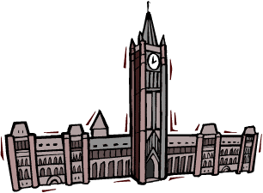



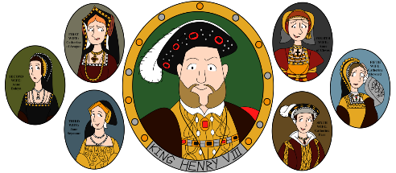Beffle Medium

Beffle Medium



* The Christian calendar influences UK public holidays, e.g. Christmas and Easter   
  are still widely celebrated in UK
* School holidays fall over these times and many businesses will close
* Other Christian festivals, e.g. St. Valentine’s Day are also celebrated, though for   
  most people the religious context of the day is no longer important and it has   
  become more of a ‘secular’ festival, celebrating romantic love
* Today, many people of other religious traditions may take time off work to celebrate their own festivals
* Bonfire night is celebrated in UK. It remembers the Gunpowder Plot, when plotters   
  led by Guy Fawkes, attempted to blow up parliament.
* Some non-religious festivals, e.g. Notting Hill Carnival that happens each   
  summer in London, celebrate the diversity of modern Britain with no   
  specific focus on religion
* Non-religious groups, such as Humanists, might recognise World   
  Humanist Day (in June) or Human Rights Day (in December) but they   
  are not widely celebrated in UK





‘Keep holy the Sabbath day’, is a Commandment. Traditionally Christians go to   
church on a Sunday and it was thought of as a ‘day of rest’. As a result, the hours that  
 shops can trade on a Sunday are restricted

In a UK court, witnesses swear on the Bible that they are telling the truth. If they are from another religious tradition, they can choose to swear on their own holy book.   
Non-religious people can make a ‘witness affirmation’ where they promise to tell   
the truth without reference to a holy book.

Christian hymns and readings are often made at public events, for example the   
National Service of Remembrance held each year to commemorate those who   
died in the Second World War.

Lots of people in UK mark important life events, like marriage in a church,   
even if they are not religious







Beffle Medium