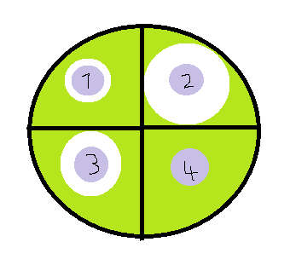
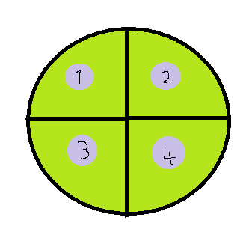
Three days later

Beginning of experiment
A doctor is trying to find the most effective antibiotic to use on a patient suffering with a bacterial throat infection. He incubates the agar for three days and can’t decide which antibiotic to use. The agar plates above show the results of the effectiveness of four different antibiotics on the Streptococcal pharyngitis bacteria before and after they were incubated.
- Which is the most effective antibiotic and why?

………………………………………………………………………………………………………………………………………………

………………………………………………………………………………………………………………………………………………

- Which is the least effective antibiotic and why?

………………………………………………………………………………………………………………………………………………

………………………………………………………………………………………………………………………………………………

- The patient takes a two week course of antibiotics but feels fine after 10 days. She decides to stop taking the antibiotic but becomes ill again a few days later. Why did the patient become ill again?

………………………………………………………………………………………………………………………………………………

………………………………………………………………………………………………………………………………………………

- Why could this antibiotic not be used to treat a viral infection?

………………………………………………………………………………………………………………………………………………

………………………………………………………………………………………………………………………………………………

