

If all things are part of the will of God, then that must include suffering, pain, disease and disasters. It is easy to see how good can come out of things which cause suffering, like training to run a marathon, but harder to understand how hurricanes and wars can be seen in a positive way. Islam teaches that painful experiences need to be viewed as opportunities for our own growth as human beings.

Islam teaches that we all have free will and God will hold us accountable for our decisions on the Day of Judgement. Humans are not puppets or robots; we have the ability to choose right from wrong. God wants us to follow the ‘straight path’, but it is up to us to make the right choices. Central to Islamic thought is the idea that life is a test and we need to learn how to turn away from evil.

*“He may let them taste part of [the consequence of] what they have done that perhaps they will return [to righteousness].”* (Qur’an 30:41)

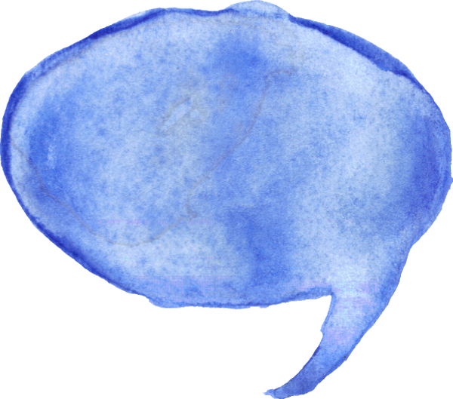

**Insha’Allah, if God is willing**

Muslims believe that things which some people might call coincidences are, in fact, part of God’s plan. The word ‘Insha’Allah’ expresses the belief that all events are outside of our own control; they are in the hands of God. When a Muslim says Insha’Allah they are acknowledging that they are in submission to God. They will only succeed in their plans if God is also willing to make it happen.

Everything is part of a  
 larger plan

Muslims believe that we can never know the reasons behind the universe, but that it is all part of a larger picture. God is the all-knowing one; his knowledge is complete and perfect. He even knows the secrets of our   
hearts.

*“He knows what is   
within the heavens and   
 the earth and knows what   
 you conceal and what you declare.   
 And God is Knowing of that within   
 the breasts.”* (Qur’an 64:4)



Islam teaches that God is responsible for all things and that   
he has a divine plan for all of us (al-Qadr). God has a master plan; everything that happens is predestined to take place; it is all part of his design. He is the cause of all things and the whole of creation is under his control. God knows all things in the greatest detail, with accuracy that we, as human,   
could never imagine.



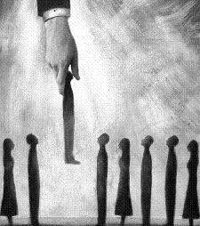



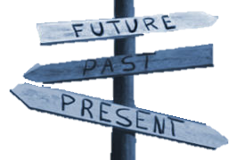





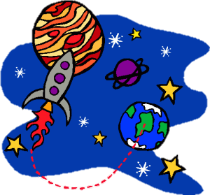

Aliens & cows Regular



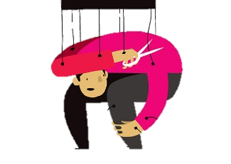

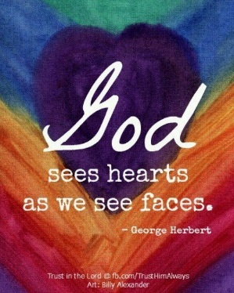



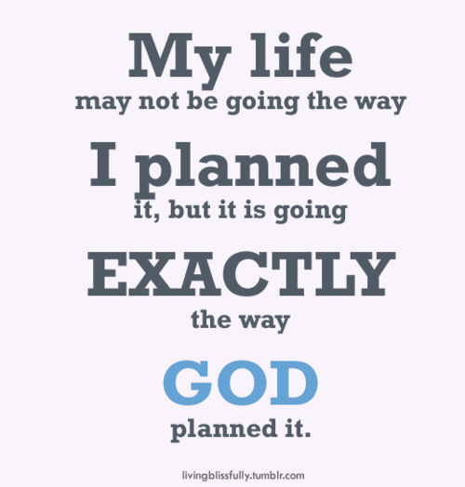





Aliens & cows Regular