Themes
By a theme we mean an idea that runs through a text. A text may have one theme or many. Understanding these makes the text more than 'just' a text - it becomes something more significant because we are encouraged to think more deeply about the story; about how it connects to real-life issues, and what it might mean to us.

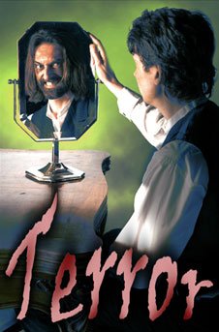
The duality of human nature
In Chapter 10, Jekyll writes clearly about the dual nature of human beings. He says that, as a young, educated man from a respectable family, he maintained an appearance of good behaviour at all times. But he says this was a fraud - no one suspected his true nature, which was at times extremely immoral.
Jekyll's experiments began in an attempt to separate the two sides of human nature and destroy the evil one. He discovered that the evil part of his nature was, indeed, part of himself, and therefore, in some sense, natural and part of the whole.

Science and the unexplained
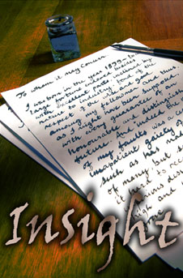
Jekyll and Lanyon are both scientists. Science traditionally explains the real world by means of experiment and observation. Scientists are usually dismissive of the supernatural, and Lanyon has avoided Jekyll for ten years because of his 'fanciful' and 'wrong minded' ideas and investigations.
By contrast, in his final 'confession', Jekyll says his investigations "led wholly towards the mystic and the transcendental". He is fascinated by the mystery of human nature - and such investigations could be seen as closer to religion and psychology than traditional 19th-century science.
There is a 'war of attitudes' between Jekyll and Lanyon, and both men are destroyed by their beliefs. Lanyon by his inability to imagine or accept a world beyond the rational and scientific; Jekyll by accepting and unleashing the dark powers that lie beyond.
Stevenson asks the reader to examine for themselves which man comes closer to the truth.

The law and the unexplained
Utterson represents the standards of conventional society and the law. Like Lanyon, he does not have the imagination to understand what Jekyll is doing.
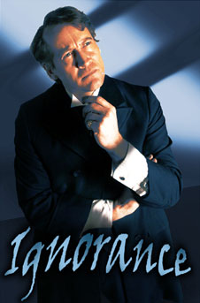
That is why Jekyll cannot confide in him about what is happening, even though they are old friends. It is also why, throughout the novel, Stevenson makes Utterson come to all the wrong conclusions. The law blinds him to the truth. It is because Utterson is a lawyer that he constantly suspects Hyde is blackmailing Jekyll or has some other criminal purpose.
The ultimate failure of Utterson (and therefore the law) is built into the structure of the novel. At the end of Chapter 8, The Last Night, Utterson promises the servant, Poole: "I shall be back before midnight, when we shall send for the police." But neither he nor the police (the other arm of the law) are heard of again. Their silence is like the death of Lanyon; they have no power to deal with the unexplained that Jekyll has unleashed.

The names Jekyll and Hyde
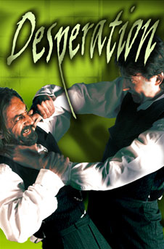
The two names seem to have a double meaning. The two syllables of Jekyll's name (Je and kyll) perhaps mean 'I kill' (Je is the French for I). In the last chapter, Jekyll describes how he tried to get rid of (kill) the Hyde in him.
Hyde spelled as 'hide' suggests something hidden from view, or the rough skin of an animal. Jekyll is in some way trying to kill the hidden Hyde and his animal nature.

The size and age of Jekyll and Hyde
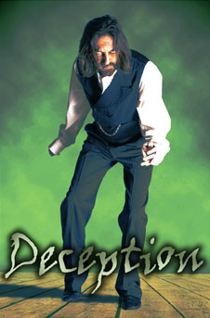
Jekyll is much bigger than Hyde. This is seen particularly when Hyde's small body is found in the much larger clothes of Dr Jekyll. The author is perhaps suggesting Hyde is a smaller part of Jekyll, but that if people repress the bad in them it will take over and destroy them.
Hyde is younger and more energetic than Jekyll. This suggests evil is something that develops later in life, after a period of childhood innocence. It also suggests Stevenson felt there is something primitively energetic and exciting about mankind's baser nature; that the 'higher', respectable nature of social humans is repressed and tame.

