Characters
Although we eventually discover that Dr Jekyll and Mr Hyde are the same person, for most of the novel we are led to believe they are different characters, so we will discuss them separately.

Dr Henry Jekyll
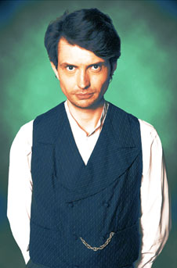
- Jekyll is a doctor and experimental scientist.
- He is wealthy and respectable.
- He has been a sociable person in the past, with a circle of friends including the lawyer, Utterson, and another doctor, Lanyon.
- During the course of the novel his behaviour becomes increasingly erratic.
- His will states that if he disappears he leaves everything to Hyde. His oldest friend, Utterson, knows nothing of Hyde and urges Jekyll to change his will. He fears Hyde has a mysterious, perhaps criminal, hold over Jekyll, and that Hyde might murder him to benefit from the will.
- In the last chapter we learn that Jekyll has been carrying out experiments to separate his personality (the 'evil' part embodied in Hyde) from his higher nature. Hyde eventually becomes more powerful and takes over.

Mr Edward Hyde
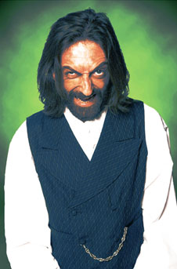
He is described as small ('dwarfish') and young.
- People react with horror and fear when they see him. But there is no single thing about him that is especially unpleasant; it is as if his spirit affects people.
- He is violent, and has no sense of guilt about his crimes. In Chapter 1, Hyde assaults a young girl, and in Chapter 4 he beats an elderly gentleman to death. He has no motive for either of these attacks.
- His appearances in the novel are always brief. People only catch impressions of him, before he vanishes into the dark or behind a door.
- Hyde is very secretive.

Gabriel Utterson
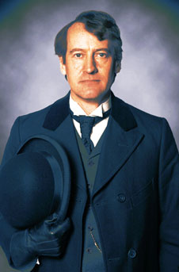
- Utterson is an old friend of Jekyll, and his lawyer.
- He is calm and rational, just as lawyers are supposed to be. Rather like a scientist, his approach in life is to weigh up the evidence.
- Utterson is 'a lover of the sane and customary sides of life'. Stevenson probably uses him to represent the attitudes of the average reader of his time.
- His sense of shock and horror when he first meets Hyde is, by contrast to his normal reaction to things, irrational: 'not all these points together could explain the hitherto unknown disgust, loathing and fear with which Mr Utterson regarded him.'
- He spends much of the novel trying to advise and help Jekyll, giving advice about his will and avoiding Hyde, and trying to help him when he shuts himself in his room. Jekyll recognises that he is a good friend, but rejects all his offers of help.
- At no stage does he suspect Jekyll and Hyde are the same person. However, he makes observations whereby the reader can, looking back, see the evidence. For instance, he asks his chief clerk, Mr Guest, to look at Hyde's handwriting. When Guest sees that Hyde's and Jekyll's writing is strangely similar, though with different directions of slope, Utterson draws the wrong conclusion: that Jekyll has forged Hyde's handwriting to protect him.
- In Chapter 8, Utterson goes home to read the documents found in Jekyll's laboratory and promises Jekyll's servant he will return before midnight. The novel ends with two chapters containing the two documents he goes home to read. The reader never discovers Utterson's reaction to them, or what action he takes. He is left as an uncompleted character. This is perhaps Stevenson's way of showing that sensible, rational people do not always have all the answers.

Dr Hastie Lanyon
- Lanyon is, like Jekyll, a doctor.
- He and Jekyll were once close friends and went to medical school together.
- Lanyon is respectable and conventional. He follows all the rules and obeys the law.
- He believes in science and the world of real, material things.
- He is a big contrast with Jekyll, who likes to live dangerously and experiment with the paranormal (what Jekyll calls 'transcendental medicine').
- He disagrees with Jekyll's ideas and calls them 'scientific balderdash (nonsense)'. In Chapter 2, Lanyon has not seen Jekyll since he started to become 'too fanciful' and 'wrong in mind'.
- Dr Jekyll, on the other hand, regards him as 'hidebound' (conventional and unadventurous) in his attitude to medical science.
- Lanyon is the only person to actually see Hyde transforming into Jekyll, something that does not fit the laws of science. When he sees the change, he cannot cope with the fight between his common-sense view of the world and what Jekyll's experiments reveal. "I ask myself if I believe it, and I cannot answer. My life is shaken to its roots." Not long after he becomes mentally and physically ill, and dies.

Minor characters
Richard Enfield
- A distant relative of Utterson, Enfield is a well-known man about town and the complete opposite to Utterson.
Poole
- He is Jekyll's man servant.
- Poole appears briefly in the novel from time to time, notably when Utterson goes to visit Jekyll.
- In Chapter 8, he goes to Utterson's house to report the strange goings on in Jekyll's house. He helps Utterson to break down the door.
Sir Danvers Carew
- Sir Danvers is a distinguished elderly gentleman who is beaten to death by Hyde. This is a turning point in the novel.
Mr Guest
- Mr Guest is Utterson's secretary and a handwriting expert. In Chapter 5, he comments on the remarkable similarity between Jekyll and Hyde's handwriting.

