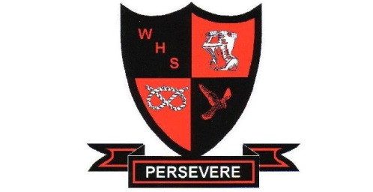
SIXTH FORM APPLICATION
WALTON MULTI ACADEMY TRUST

Surname |  |  | Forename
Date of Birth |  |  | Student Email
Phone (Home) |  |  | Student Mobile
Address
Current School
Parent/Guardian
Parent Telephone
Do you have any health problems that we need to be aware of? |  | Yes/No
Do you have a learning difficulty or disability? |  | Yes/No
Do you have any support at your current school to assist you? |  | Yes/No
Education
Examinations to be taken
Exam (e.g. GCSE) | Subject
Qualifications already obtained
Exam | Subject | Date taken | Result/Grade
SIXTH FORM OPTIONS
Please select one subject per option block to ensure there is no clash on your timetable.
(Refer to our Sixth Form Course Guide for more information).
Students will typically study 3 academic A Levels or 3 vocational courses, or, a mix of both subject to students meeting our Sixth Form course criteria.
Block A | Block B | Block C | Block D | Block E
STUDENT COMMENT
Tell us about yourself, your career aspirations and your hopes for the future.
Who can we approach at your current school for a reference?

Personal and Equal Opportunities Information
Gender | Male/Female
Nationality
Ethnicity
Applicant’s Signature
Parent’s/Guardian’s Signature
Date
Please return your completed application form to:
Sixth Form Office
Walton High School
The Rise
Walton on the Hill
Stafford ST17 0LJ Email: sixthform@walton.staffs.sch.uk
For office use only
Received by Sixth Form Office
Date of Interview
Offer of place
Notes

